VISVESVARAYA TECHNOLOGICAL UNIVERSITY
“JnanaSangama”, Belgaum -590014, Karnataka.

LAB REPORT
on
Object Oriented Java Programming (23CS3PCOOJ)
Submitted by
Name: ABHISHEK
USN : (1BM23CS012)
in partial fulfillment for the award of the degree of
BACHELOR OF ENGINEERING
in
COMPUTER SCIENCE AND ENGINEERING

B.M.S. COLLEGE OF ENGINEERING
(Autonomous Institution under VTU)
BENGALURU-560019
Sep-2024 to Jan-2025

B.M.S. College of Engineering,
Bull Temple Road, Bangalore 560019
(Affiliated To Visvesvaraya Technological University, Belgaum)
Department of Computer Science and Engineering

CERTIFICATE
This is to certify that the Lab work entitled “Object Oriented Java Programming (23CS3PCOOJ)” carried out by ABHISHEK (1BM23CS012), who is bonafide student of B.M.S. College of Engineering. It is in partial fulfillment for the award of Bachelor of Engineering in Computer Science and Engineering of the Visvesvaraya Technological University, Belgaum. The Lab report has been approved as it satisfies the academic requirements in respect of an Object Oriented Java Programming (23CS3PCOOJ) work prescribed for the said degree.

Lab faculty Incharge Name  Assistant Professor  Department of CSE, BMSCE | Dr. Jyothi S Nayak  Professor & HOD  Department of CSE, BMSCE

Index
Sl.  No. | Date | Experiment Title | Page No.
1
2
3
4
5
6
7
8
9
10

Github Link: https://github.com/abhi863

PROGRAM:1

Develop a Java program that prints all real solutions to the quadratic equation ax2+bx+c = 0. Read in a, b, c and use the quadratic formula. If the discriminate b2-4ac is negative, display a message stating that there are no real solutions.

import java.util.Scanner;

public class QuadraticEquation {
public static void main(String[] args) {

Scanner input = new Scanner(System.in);

System.out.print("Enter coefficient a: ");
double a = input.nextDouble();
System.out.print("Enter coefficient b: ");
double b = input.nextDouble();
System.out.print("Enter coefficient c: ");
double c = input.nextDouble();

if (a == 0) {
if (b != 0) {

double root = -c / b;
System.out.println("This is a linear equation. The solution is: " + root);
} else if (c == 0) {

System.out.println("The equation has infinitely many solutions.");
} else {

System.out.println("The equation has no solutions.");
}
} else {

double discriminant = b * b - 4 * a * c;

if (discriminant > 0) {
double root1 = (-b + Math.sqrt(discriminant)) / (2 * a);
double root2 = (-b - Math.sqrt(discriminant)) / (2 * a);
System.out.println("The equation has two real solutions: " + root1 + " and " + root2);
} else if (discriminant == 0) {
double root = -b / (2 * a);
System.out.println("The equation has one real solution: " + root);
} else {
System.out.println("The equation has no real solutions.");
}
}

input.close();
}
}

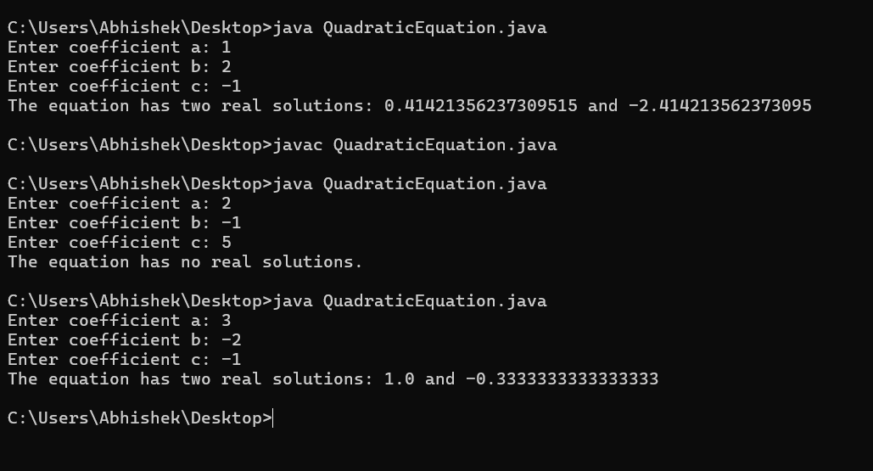
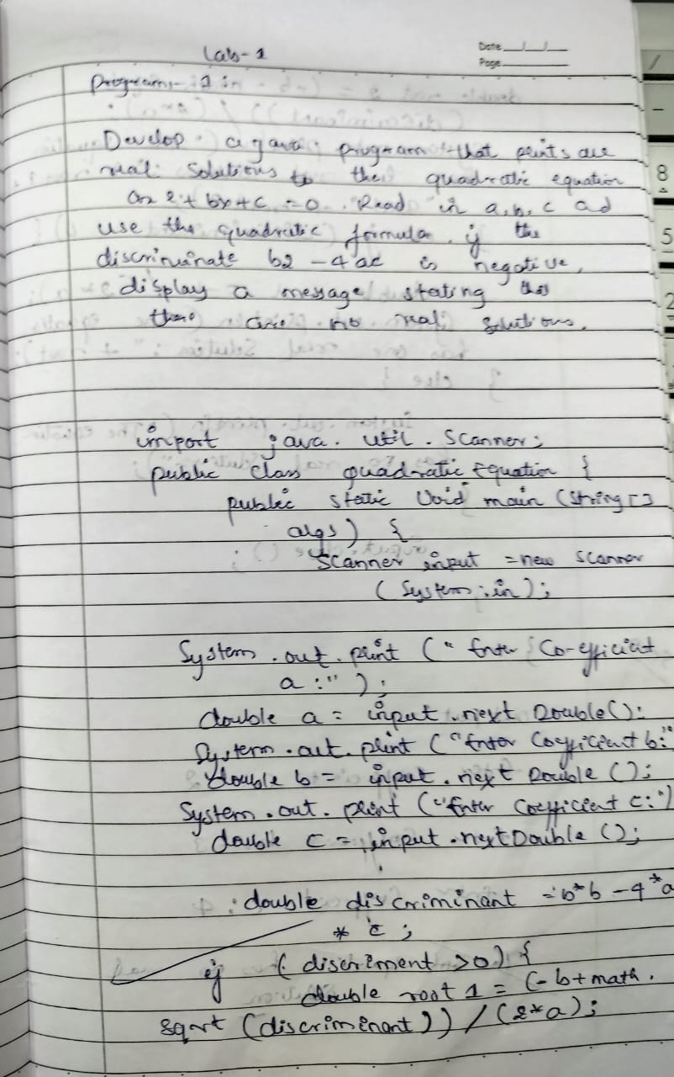

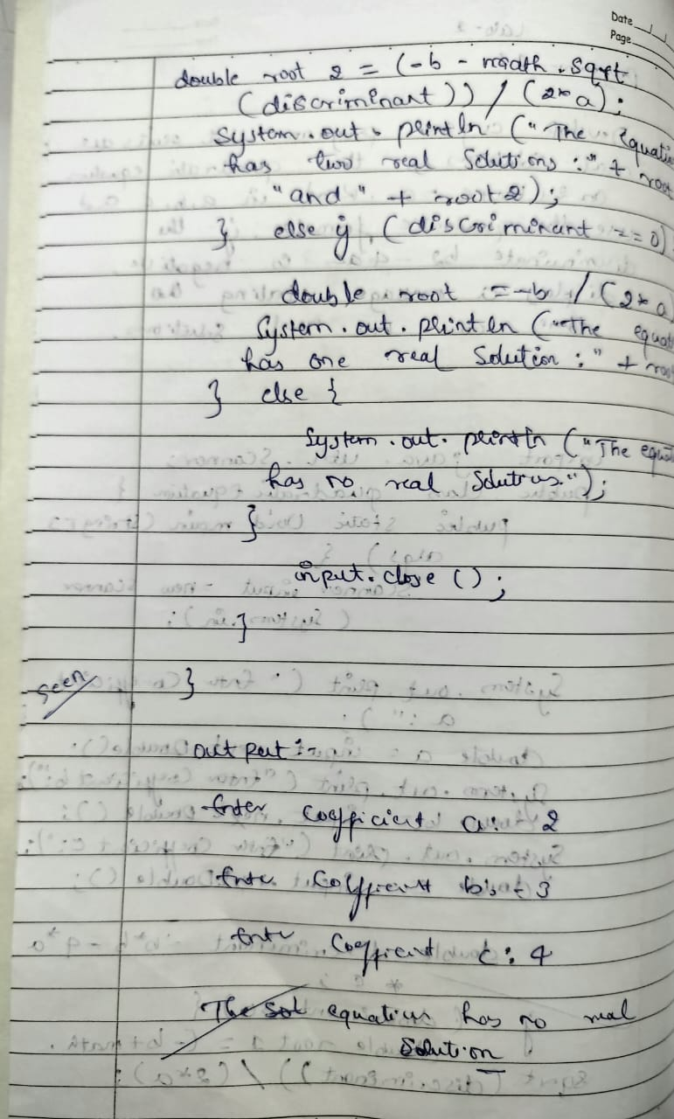
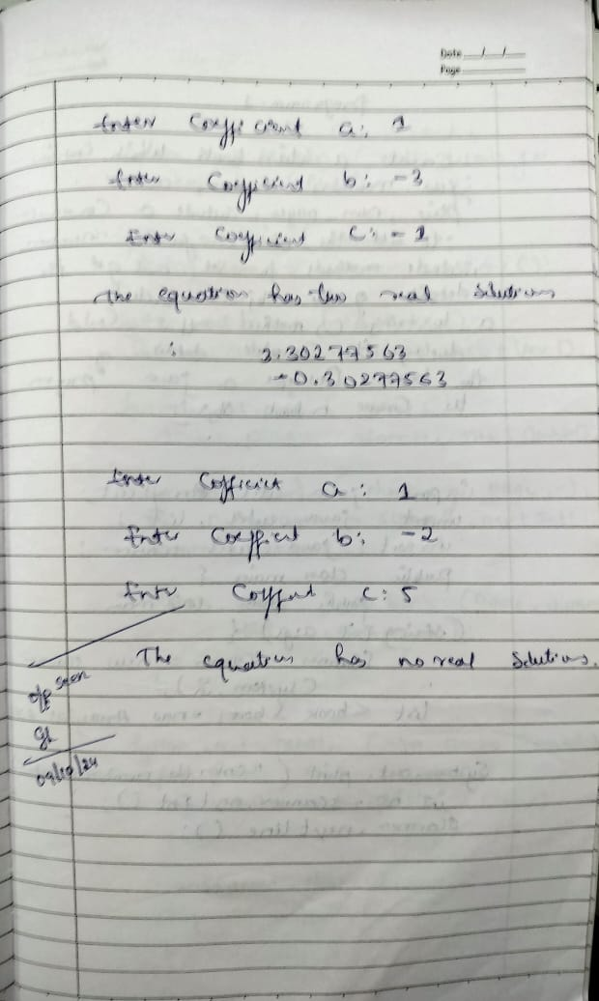

PROGRAM:2

Develop a Java program to create a class Student with members usn, name, an array credits and an array marks. Include methods to accept and display details and a method to calculate SGPA of a student.

import java.util.Scanner;

class Student {
String usn;
String name;
int[] credits;
int[] marks;

void acceptDetails() {
Scanner sc = new Scanner(System.in);

System.out.print("Enter USN: ");
usn = sc.nextLine();

System.out.print("Enter Name: ");
name = sc.nextLine();

System.out.print("Enter the number of subjects: ");
int n = sc.nextInt();

credits = new int[n];
marks = new int[n];

System.out.println("Enter credits for each subject:");
for (int i = 0; i < n; i++) {
System.out.print("Credits for subject " + (i + 1) + ": ");
credits[i] = sc.nextInt();
}

System.out.println("Enter marks for each subject:");
for (int i = 0; i < n; i++) {
System.out.print("Marks for subject " + (i + 1) + ": ");
marks[i] = sc.nextInt();
}
}

double calculateSGPA() {
int totalCredits = 0;
int weightedSum = 0;

for (int i = 0; i < credits.length; i++) {
int gradePoint = getGradePoint(marks[i]);
weightedSum += gradePoint * credits[i];
totalCredits += credits[i];
}

return (double) weightedSum / totalCredits;
}

int getGradePoint(int marks) {
if (marks >= 90) return 10;
else if (marks >= 80) return 9;
else if (marks >= 70) return 8;
else if (marks >= 60) return 7;
else if (marks >= 50) return 6;
else if (marks >= 40) return 5;
else return 0;
}

void displayDetails() {
System.out.println("\nStudent Details:");
System.out.println("USN: " + usn);
System.out.println("Name: " + name);
System.out.println("SGPA: " + calculateSGPA());
}

public static void main(String[] args) {
Student student = new Student();
student.acceptDetails();
student.displayDetails();
}

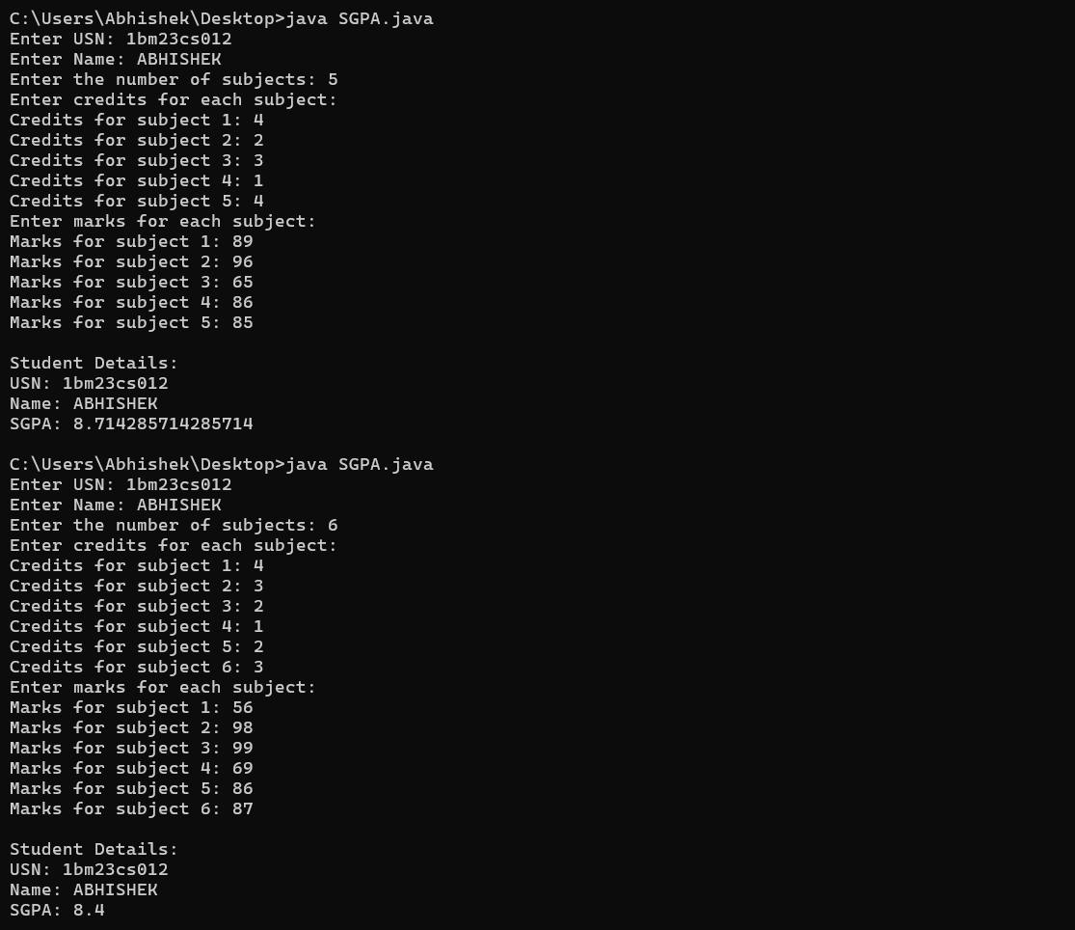

PROGRAM :3

Create a class Book which contains four members: name, author, price, num_pages. Include a constructor to set the values for the members. Include methods to set and get the details of the objects. Include a toString( ) method that could display the complete details of the book. Develop a Java program to create n book objects.

import java.util.ArrayList;
import java.util.List;
import java.util.Scanner;

public class Main {
public static void main(String[] args) {
Scanner scanner = new Scanner(System.in);
List<Book> books = new ArrayList<>();

System.out.print("Enter the number of books: ");
int n = scanner.nextInt();
scanner.nextLine();

for (int i = 0; i < n; i++) {
System.out.println("Enter details for book " + (i + 1) + ":");

System.out.print("Name: ");
String name = scanner.nextLine();

System.out.print("Author: ");
String author = scanner.nextLine();

System.out.print("Price: ");
double price = scanner.nextDouble();

System.out.print("Number of Pages: ");
int numPages = scanner.nextInt();
scanner.nextLine();

books.add(new Book(name, author, price, numPages));
}

System.out.println("\nBooks Entered:");
for (Book book : books) {
System.out.println(book);
}

scanner.close();
}
}

class Book {

private String name;
private String author;
private double price;
private int numPages;

public Book(String name, String author, double price, int numPages) {
this.name = name;
this.author = author;
this.price = price;
this.numPages = numPages;
}

public void setName(String name) {
this.name = name;
}

public void setAuthor(String author) {
this.author = author;
}

public void setPrice(double price) {
this.price = price;
}

public void setNumPages(int numPages) {
this.numPages = numPages;
}

public String getName() {
return name;
}

public String getAuthor() {
return author;
}

public double getPrice() {
return price;
}

public int getNumPages() {
return numPages;
}

@Override
public String toString() {
return "Book Details: \n" +
"Name: " + name + "\n" +
"Author: " + author + "\n" +
"Price: $" + price + "\n" +
"Number of Pages: " + numPages;
}
}

OUTPUT:

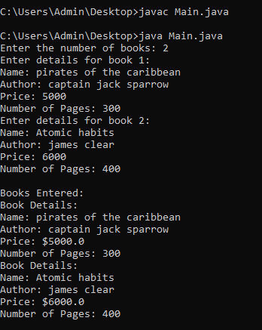

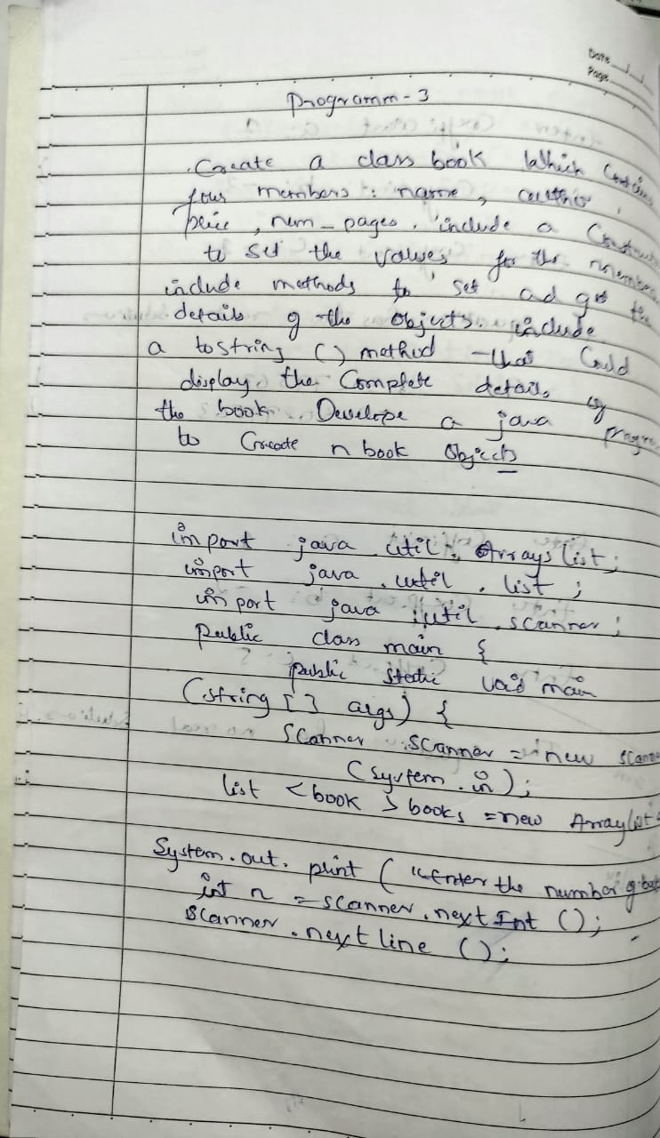
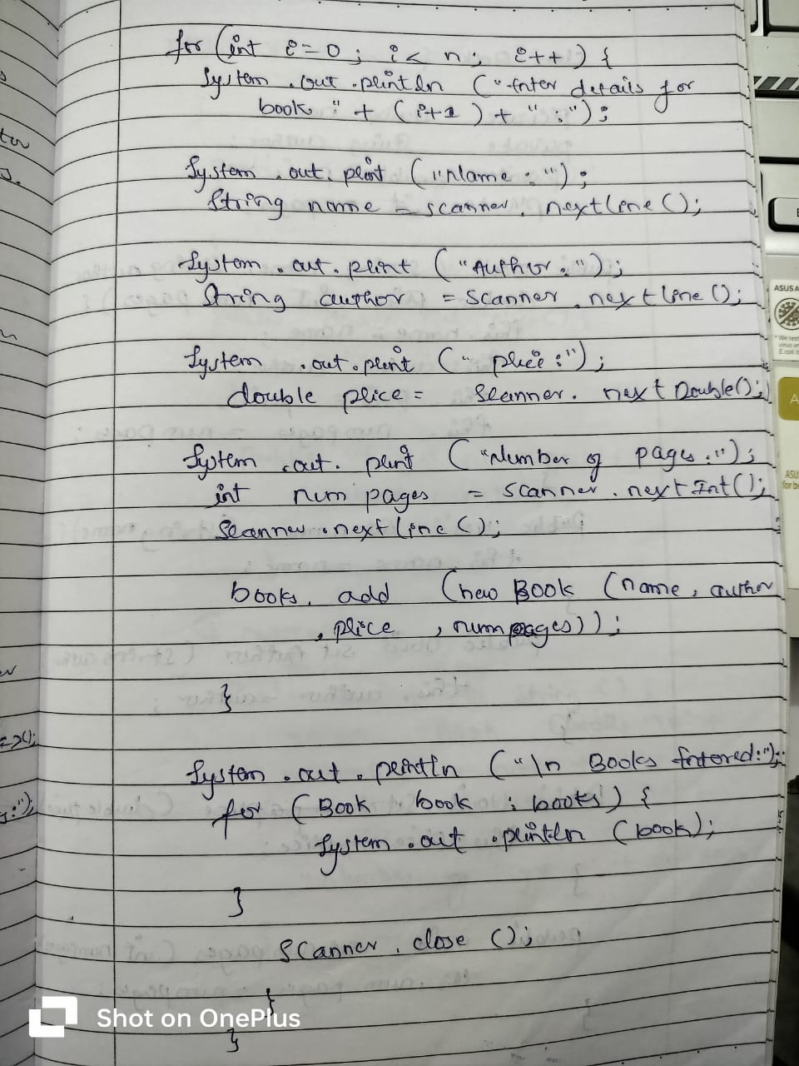
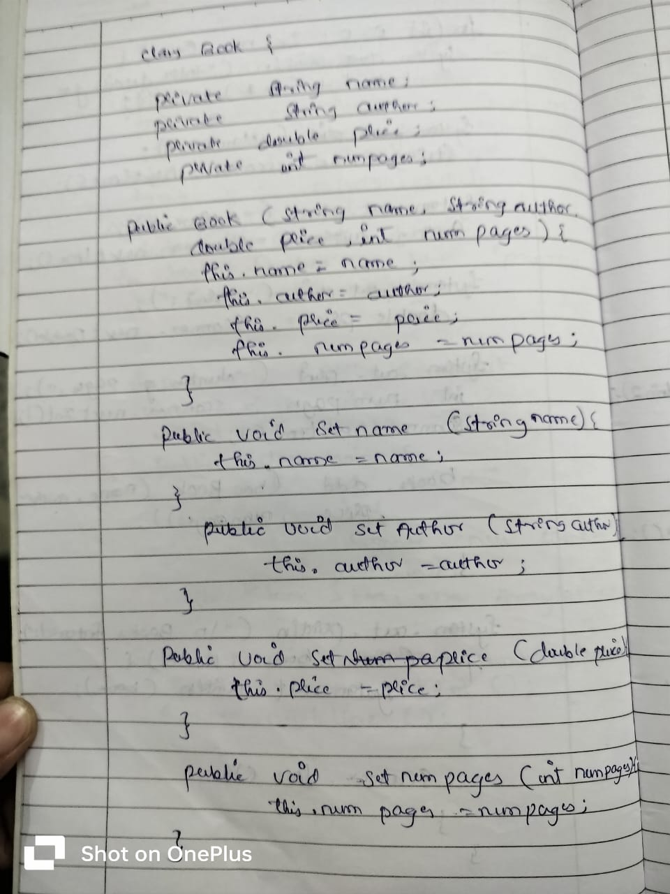
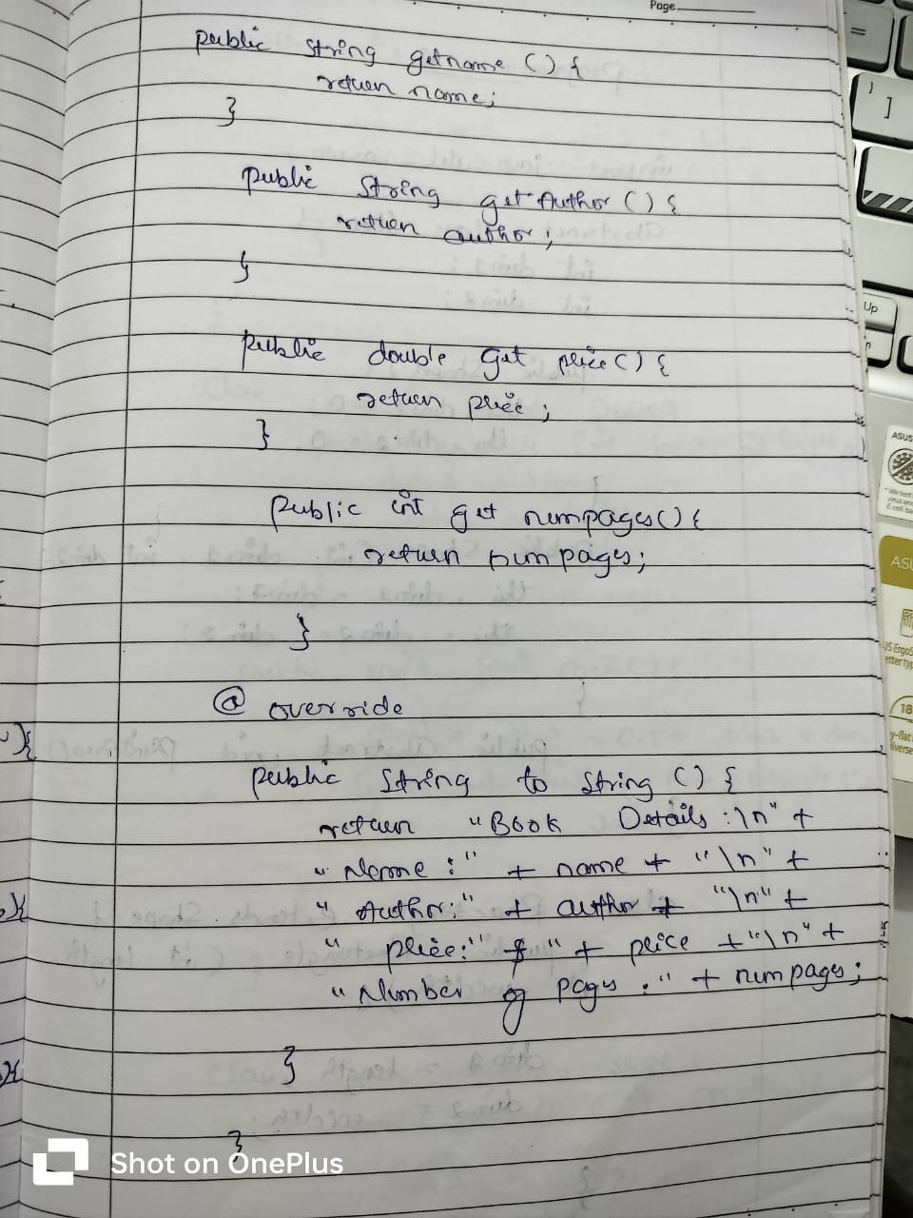
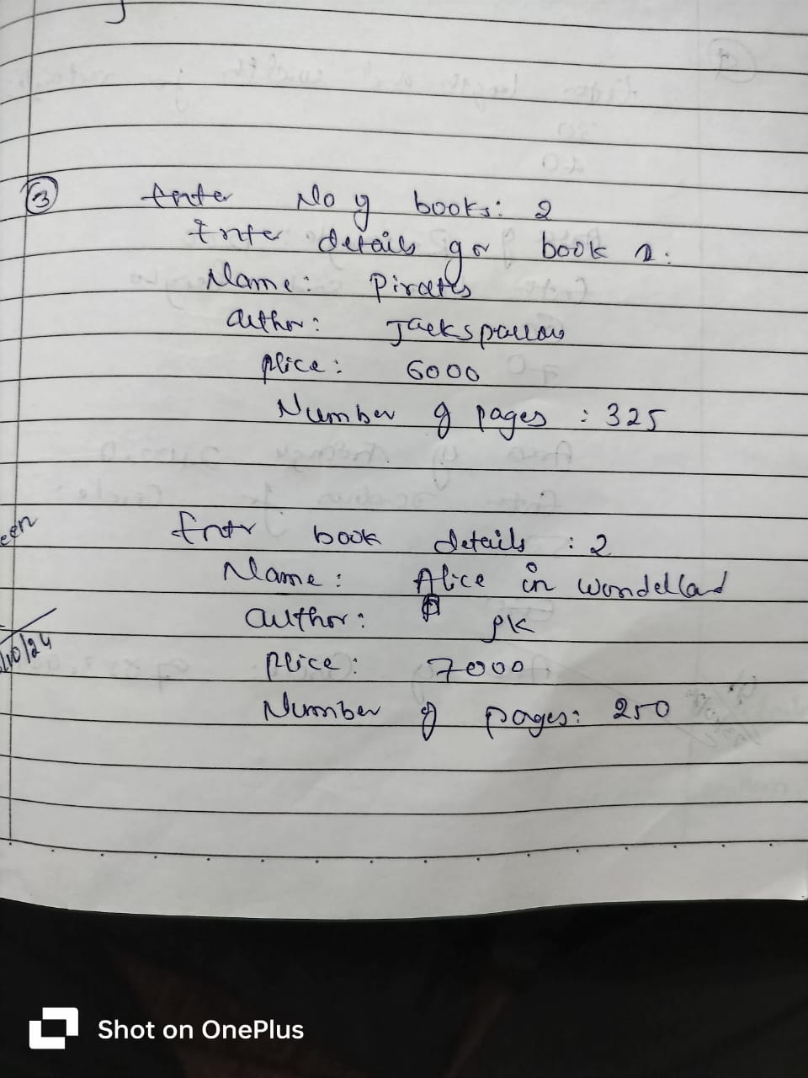

PROGRAM :4

Develop a Java program to create an abstract class named Shape that contains two integers and an empty method named printArea( ). Provide three classes named Rectangle, Triangle and Circle such that each one of the classes extends the class Shape. Each one of the classes contain only the method printArea( ) that prints the area of the given shape.

import java.util.Scanner;

abstract class Shape {
int dim1;
int dim2;

public Shape() {
this.dim1 = 0;
this.dim2 = 0;

}

public Shape(int dim1, int dim2) {
this.dim1 = dim1;
this.dim2 = dim2;
}

public abstract void printArea();

}

class Rectangle extends Shape {
public Rectangle(int length, int width) {
dim1 = length;
dim2 = width;
}

public void printArea() {

int area = dim1 * dim2;
System.out.println("Area of Rectangle: " + area);

}
}

class Triangle extends Shape {
public Triangle(int base, int height) {
dim1 = base;
dim2 = height;
}

public void printArea() {

double area = 0.5 * dim1 * dim2;
System.out.println("Area of Triangle: " + area);

}
}

class Circle extends Shape {
public Circle(int radius) {

dim1 = radius;
dim2 = 0;
}

public void printArea() {

double area = Math.PI * dim1 * dim1;
System.out.println("Area of Circle: " + area);
}
}

public class shapes {

public static void main(String[] args) {
Scanner in = new Scanner(System.in);

System.out.println("Enter length and width for Rectangle:");

int length = in.nextInt();
int width = in.nextInt();
Shape rectangle = new Rectangle(length, width);
rectangle.printArea();

System.out.println("Enter base and height for Triangle:");

int base = in.nextInt();
int height = in.nextInt();
Shape triangle = new Triangle(base, height);
triangle.printArea();

System.out.println("Enter radius for Circle:");

int radius = in.nextInt();
Shape circle = new Circle(radius);
circle.printArea();

in.close();
}
}

OUTPUT:
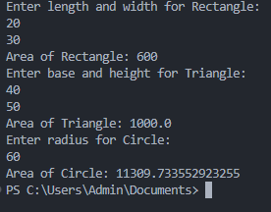

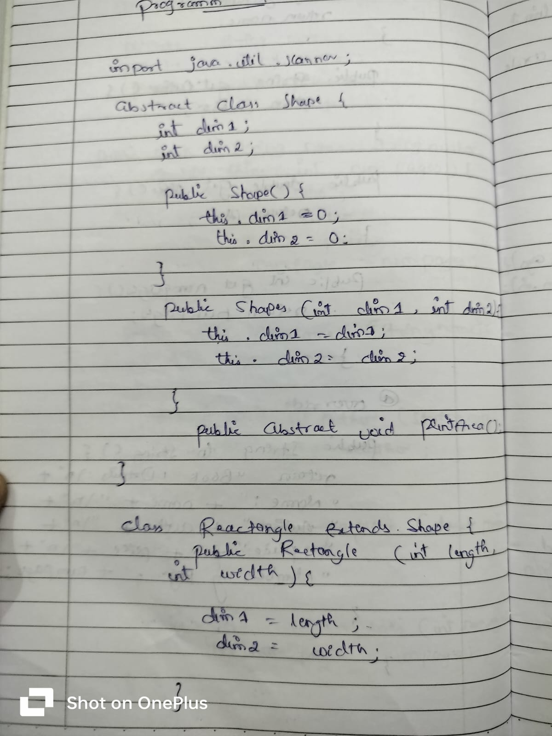
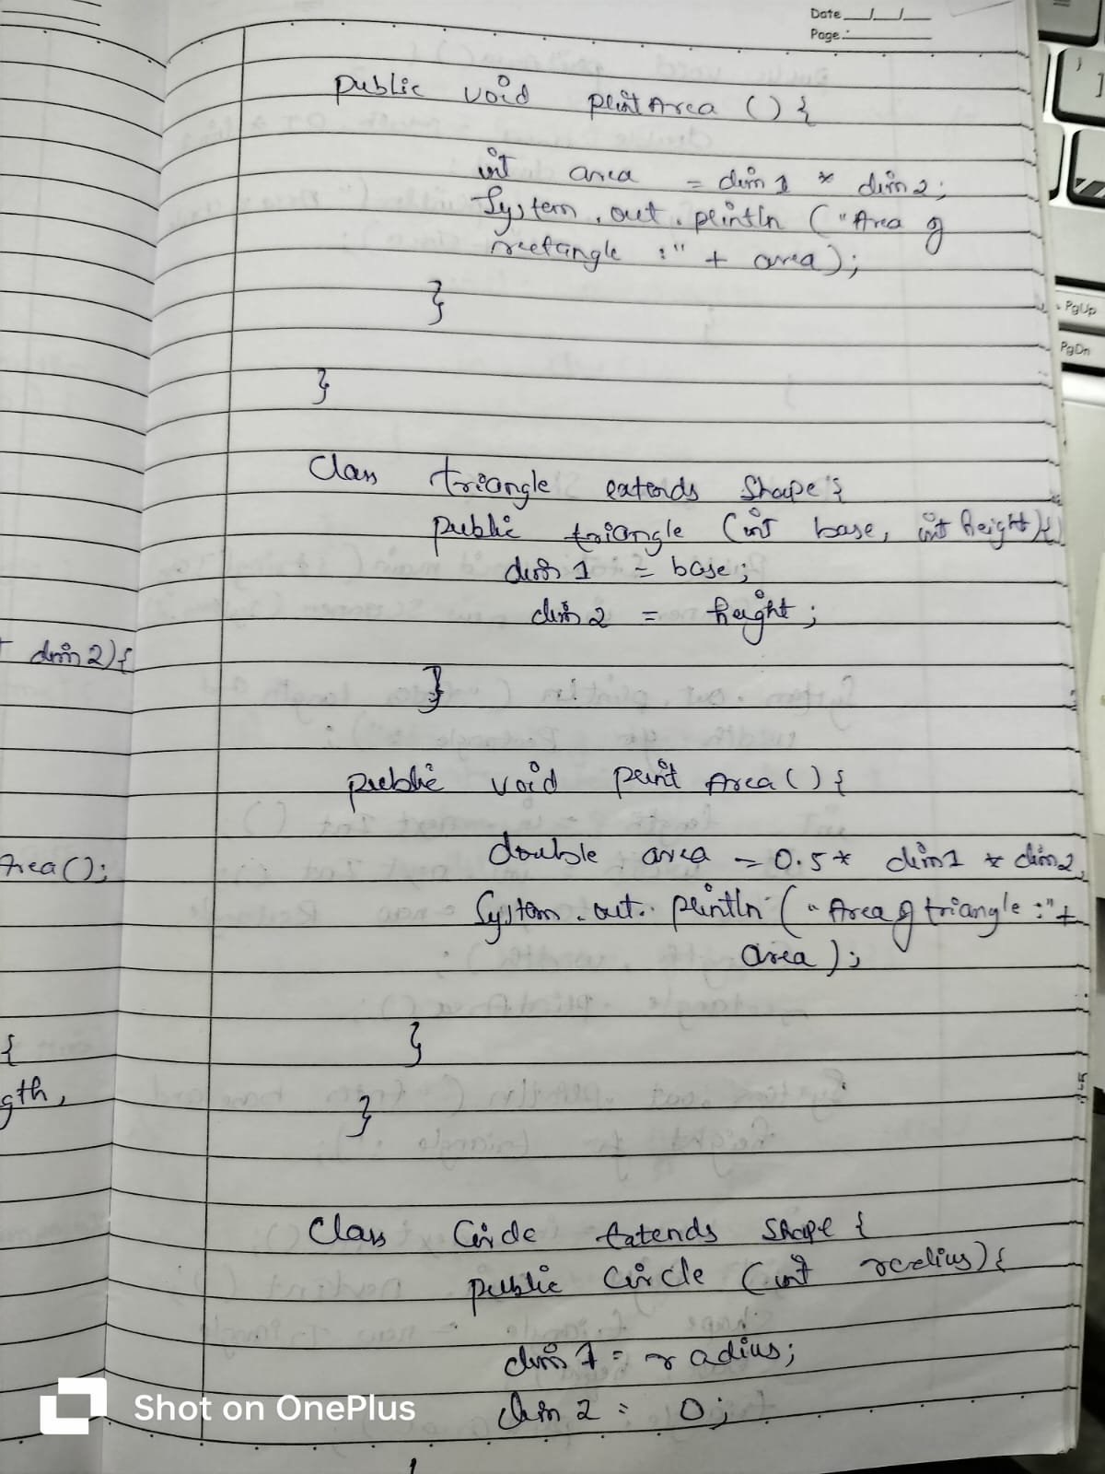
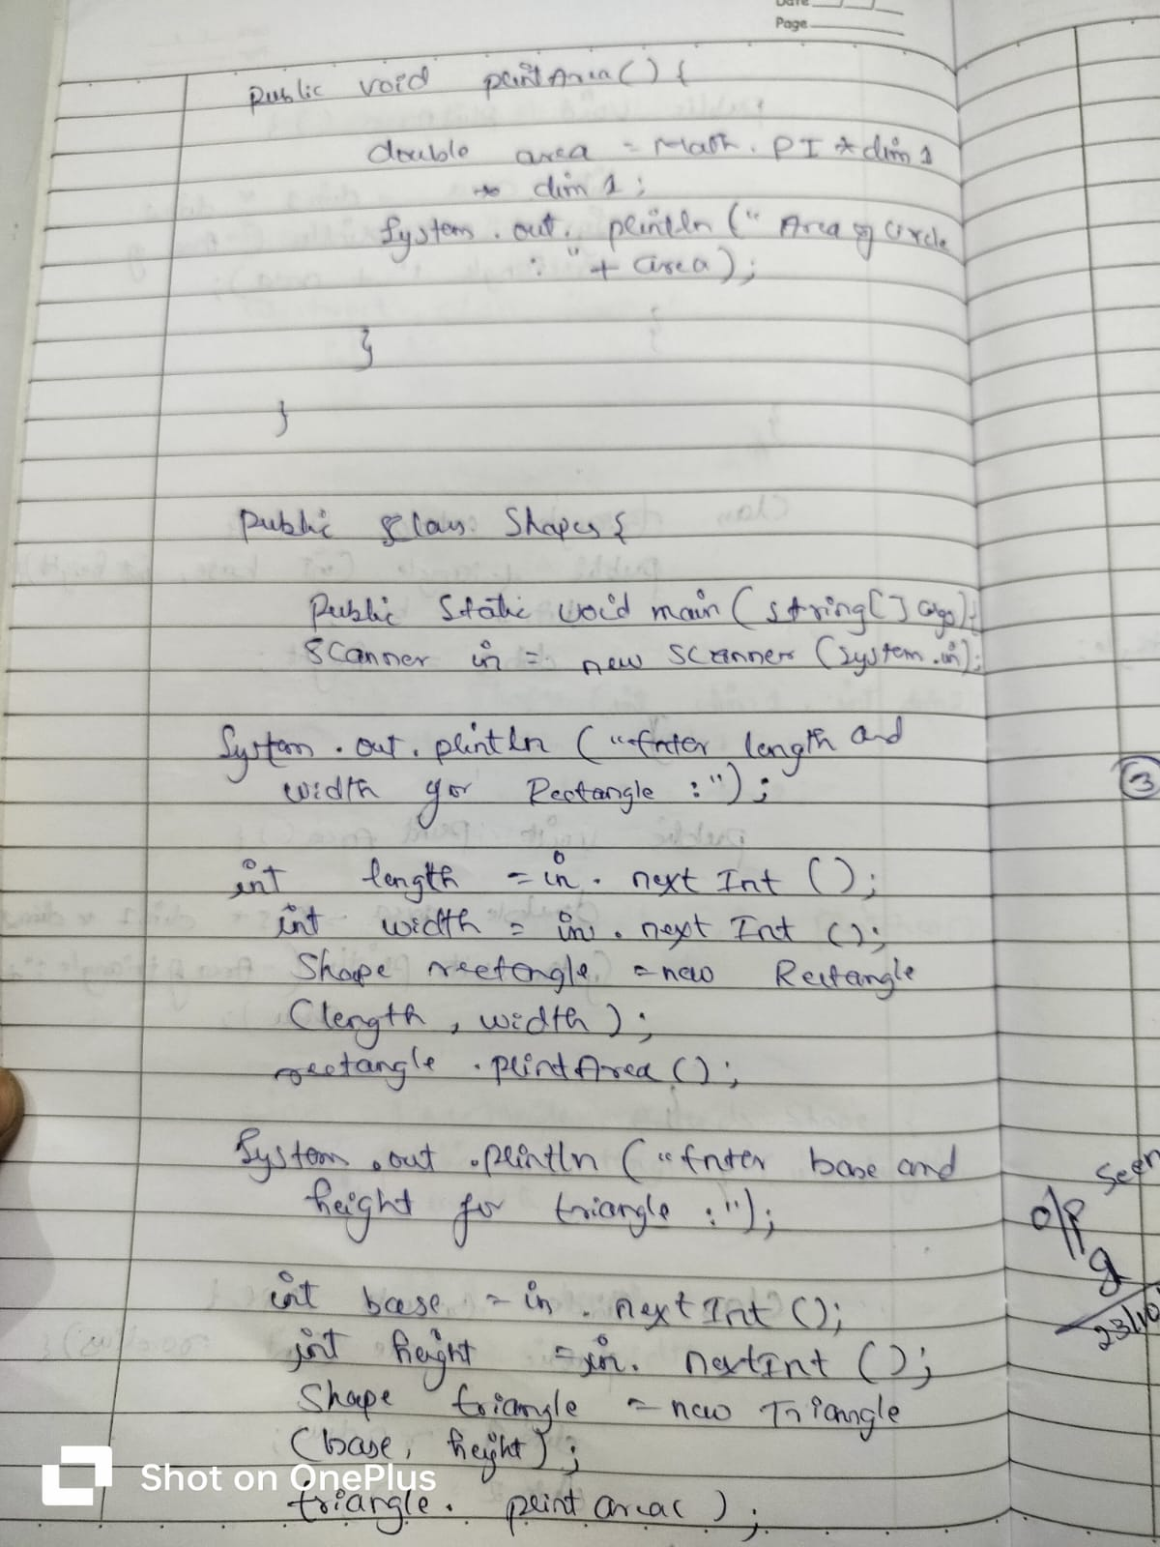
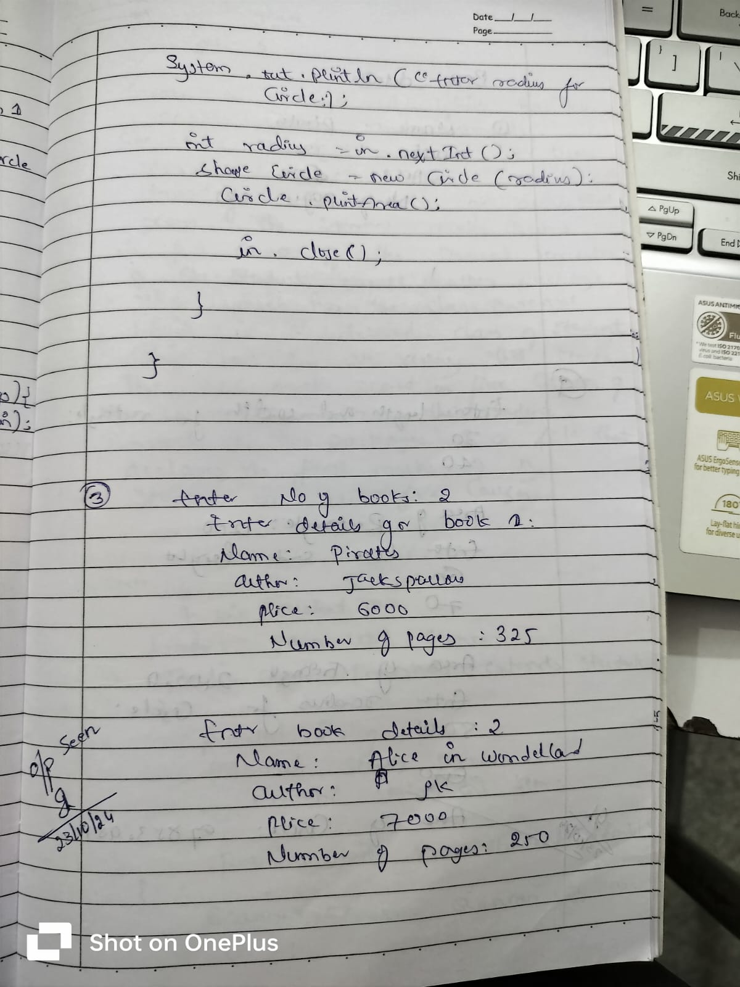

PROGRAM :5

Develop a Java program to create a class Bank that maintains two kinds of account for its customers, one called savings account and the other current account. The savings account provides compound interest and withdrawal facilities but no cheque book facility. The current account provides cheque book facility but no interest. Current account holders should also maintain a minimum balance and if the balance falls below this level, a service charge is imposed.
Create a class Account that stores customer name, account number and type of account. From this derive the classes Cur-acct and Sav-acct to make them more specific to their requirements. Include the necessary methods in order to achieve the following tasks:
a) Accept deposit from customer and update the balance.
b) Display the balance.
c) Compute and deposit interest
d) Permit withdrawal and update the balance Check for the minimum balance, impose penalty if necessary and update the balance.

import java.util.Scanner;

class Account {
protected String customerName;
protected String accountNumber;
protected String accountType;
protected double balance;

public Account(String customerName, String accountNumber, String accountType, double initialBalance) {
this.customerName = customerName;
this.accountNumber = accountNumber;
this.accountType = accountType;
this.balance = initialBalance;
}

public void displayBalance() {
System.out.println("Account Balance: " + balance);
}

public void deposit(double amount) {
if (amount > 0) {
balance += amount;
System.out.println("Deposit Successful. Updated Balance: " + balance);
} else {
System.out.println("Invalid deposit amount.");
}
}
}

class SavAcct extends Account {
private static final double INTEREST_RATE = 0.05;
public SavAcct(String customerName, String accountNumber, double initialBalance) {
super(customerName, accountNumber, "Savings", initialBalance);
}

public void computeAndDepositInterest(int years) {
double interest = balance * Math.pow(1 + INTEREST_RATE, years) - balance;
balance += interest;
System.out.println("Interest of " + interest + " deposited. Updated Balance: " + balance);
}

public void withdraw(double amount) {
if (amount > 0 && amount <= balance) {
balance -= amount;
System.out.println("Withdrawal Successful. Updated Balance: " + balance);
} else {
System.out.println("Invalid withdrawal amount or insufficient balance.");
}
}
}

class CurAcct extends Account {
private static final double MIN_BALANCE = 1000.0;
private static final double PENALTY = 50.0;

public CurAcct(String customerName, String accountNumber, double initialBalance) {
super(customerName, accountNumber, "Current", initialBalance);
}

public void withdraw(double amount) {
if (amount > 0 && amount <= balance) {
balance -= amount;
System.out.println("Withdrawal Successful. Updated Balance: " + balance);
if (balance < MIN_BALANCE) {
balance -= PENALTY;
System.out.println("Balance below minimum. Penalty of " + PENALTY + " imposed. Updated Balance: " + balance);
}
} else {
System.out.println("Invalid withdrawal amount or insufficient balance.");
}
}
}

public class Bank {
public static void main(String[] args) {
Scanner scanner = new Scanner(System.in);

SavAcct savings = new SavAcct("Alice", "S123", 5000.0);

CurAcct current = new CurAcct("Bob", "C456", 2000.0);

System.out.println("Savings Account Operations:");
savings.displayBalance();
savings.deposit(2000);
savings.computeAndDepositInterest(2);
savings.withdraw(3000);

System.out.println("\nCurrent Account Operations:");
current.displayBalance();
current.deposit(1000);
current.withdraw(2500);
current.withdraw(500);

scanner.close();
}
}

OUTPUT:

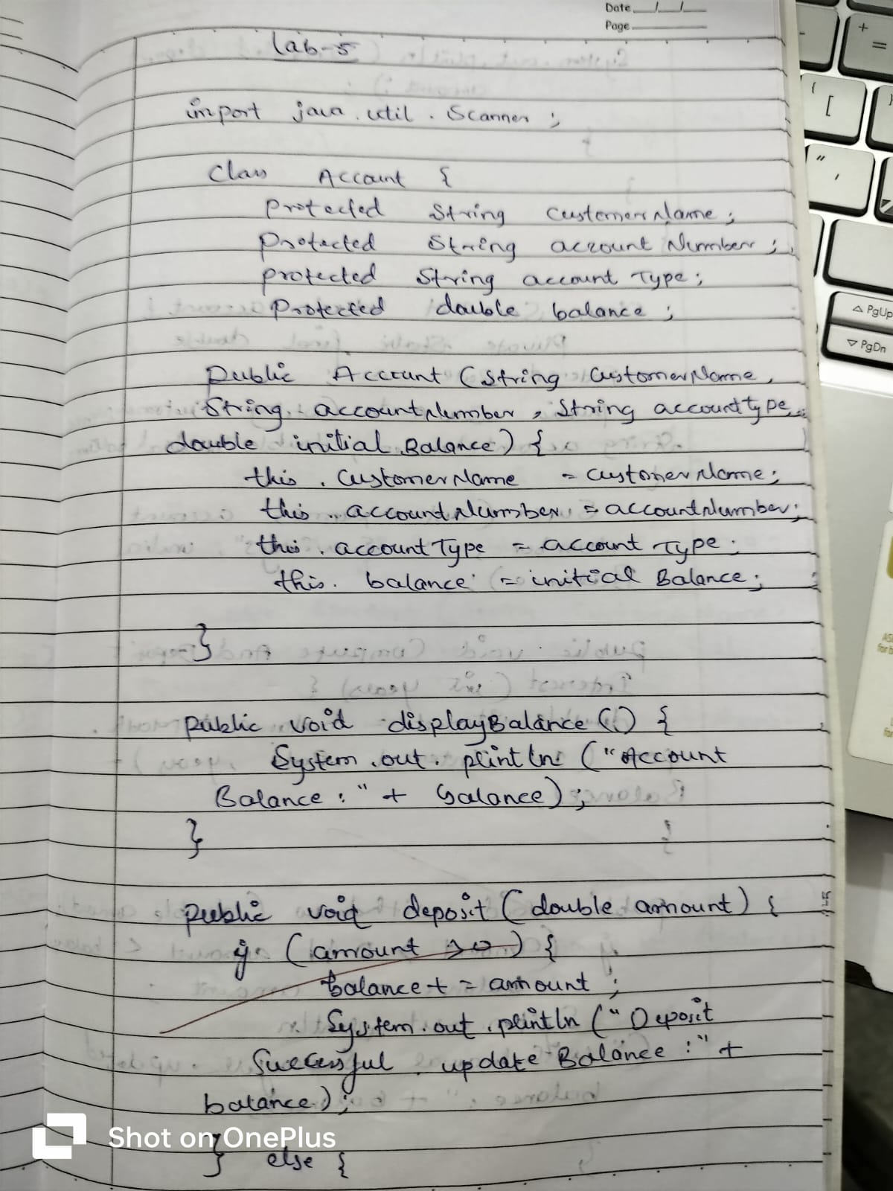
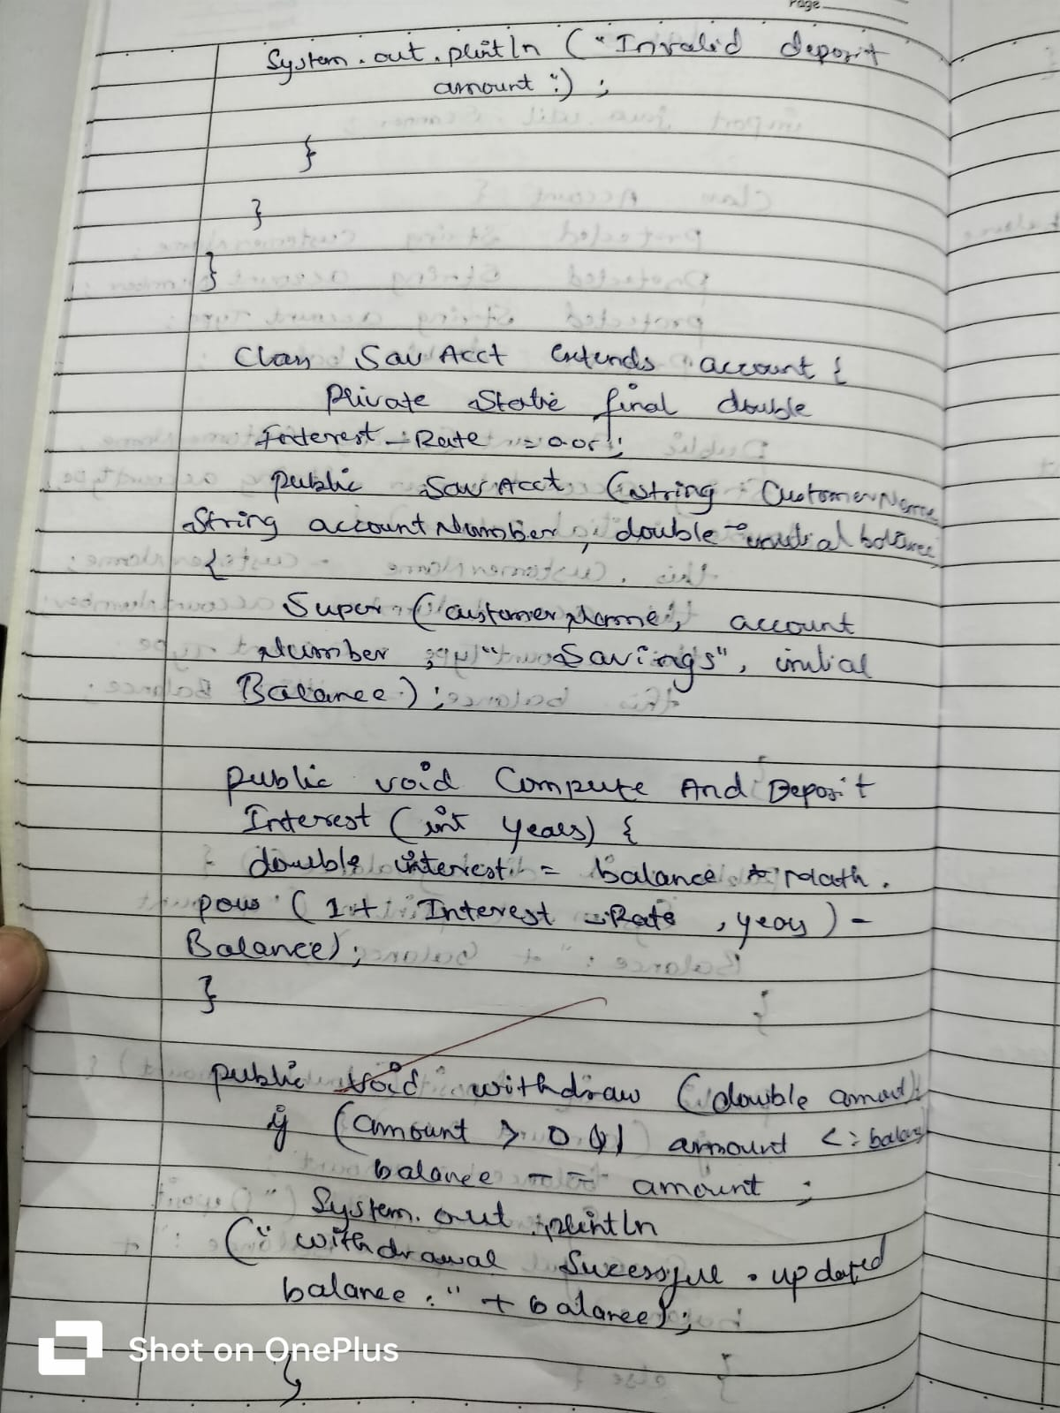
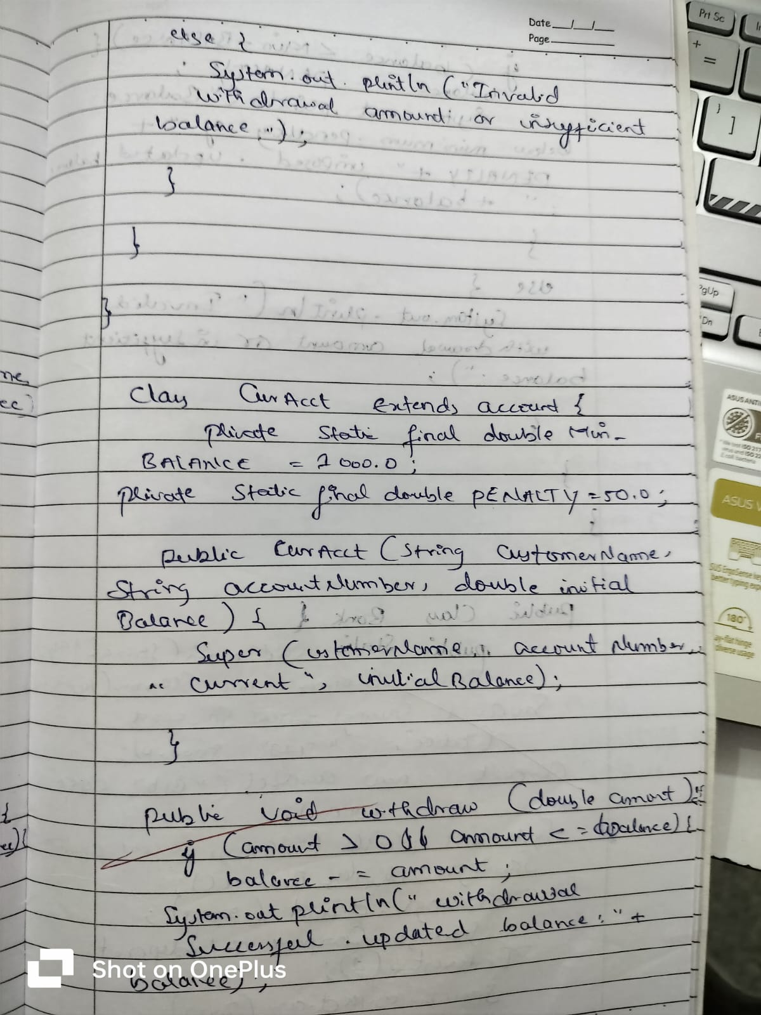
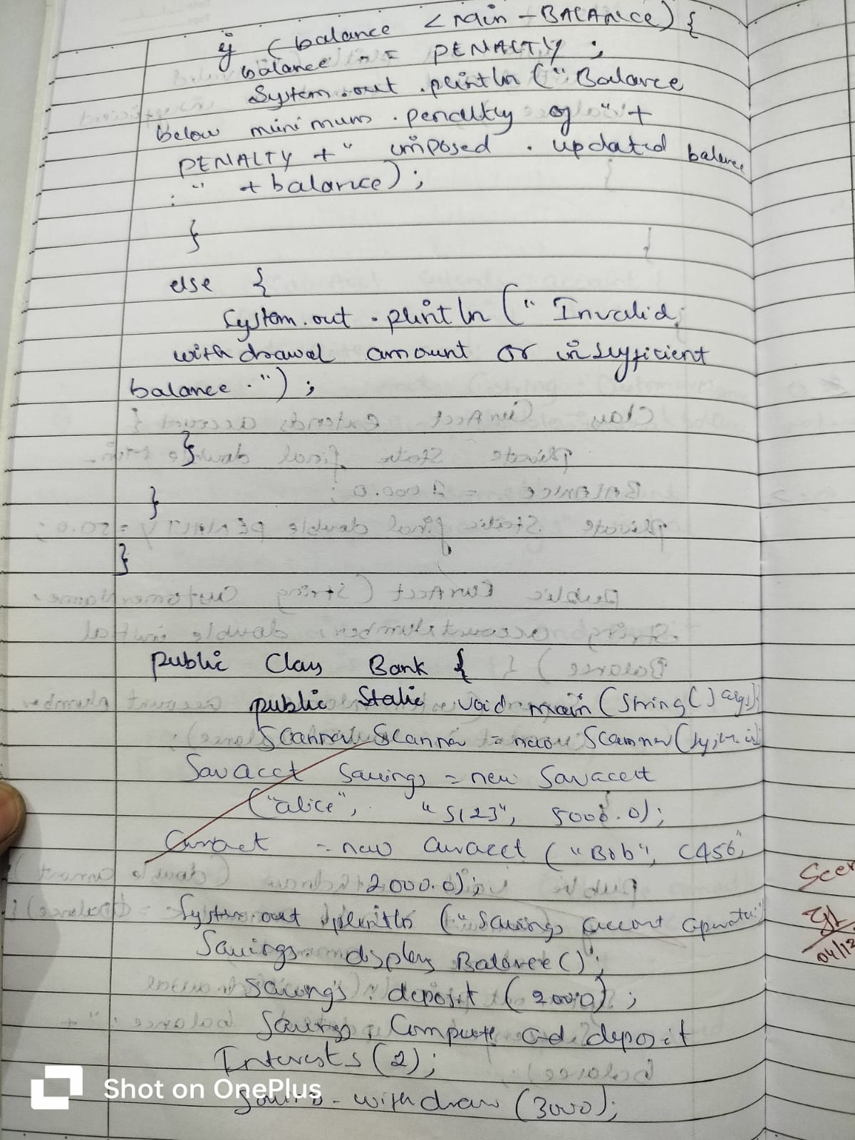

PROGRAM :6

Create a package CIE which has two classes- Student and Internals. The class Personal has members like usn, name, sem. The class internals has an array that stores the internal marks scored in five courses of the current semester of the student. Create another package SEE which has the class External which is a derived class of Student. This class has an array that stores the SEE marks scored in five courses of the current semester of the student. Import the two packages in a file that declares the final marks of n students in all five courses.

// internals.java

import java.util.Scanner;

public class Internals extends Student {
protected int[] internalMarks = new int[5];

public void inputCIEmarks() {
Scanner s = new Scanner(System.in);
System.out.println("Enter Internal Marks for 5 subjects:");
for (int i = 0; i < 5; i++) {
System.out.print("Subject " + (i + 1) + ": ");
internalMarks[i] = s.nextInt();
}
}
}

//externals.java

import java.util.Scanner;

public class Externals extends Internals {
private int[] seeMarks = new int[5];
private int[] finalMarks = new int[5];

public void inputSEEmarks() {
Scanner s = new Scanner(System.in);
System.out.println("Enter SEE Marks for 5 subjects:");
for (int i = 0; i < 5; i++) {
System.out.print("Subject " + (i + 1) + ": ");
seeMarks[i] = s.nextInt();
}
}

public void calculateFinalMarks() {
for (int i = 0; i < 5; i++) {
finalMarks[i] = internalMarks[i] + seeMarks[i];
}
}

public void displayFinalMarks() {
displayStudentDetails();
System.out.println("Final Marks for 5 subjects:");
for (int i = 0; i < 5; i++) {
System.out.println("Subject " + (i + 1) + ": " + finalMarks[i]);
}
}
}

//student.java

import java.util.Scanner;

public class Student {
protected String usn;
protected String name;
protected int sem;

public void inputStudentDetails() {
Scanner s = new Scanner(System.in);
System.out.print("Enter USN: ");
usn = s.nextLine();
System.out.print("Enter Name: ");
name = s.nextLine();
System.out.print("Enter Semester: ");
sem = s.nextInt();
}

public void displayStudentDetails() {
System.out.println("USN: " + usn);
System.out.println("Name: " + name);
System.out.println("Semester: " + sem);
}
}

//main.java

import java.util.Scanner;

class Main {
public static void main(String[] args) {
Scanner s = new Scanner(System.in);
System.out.print("Enter number of students: ");
int n = s.nextInt();

Externals[] students = new Externals[n];

for (int i = 0; i < n; i++) {
System.out.println("\nEnter details for student " + (i + 1) + ":");
students[i] = new Externals();
students[i].inputStudentDetails();
students[i].inputCIEmarks();
students[i].inputSEEmarks();
students[i].calculateFinalMarks();
}

System.out.println("\nFinal Marks of Students:");
for (int i = 0; i < n; i++) {
System.out.println("\nStudent " + (i + 1) + ":");
students[i].displayFinalMarks();
}
}
}

OUTPUT:

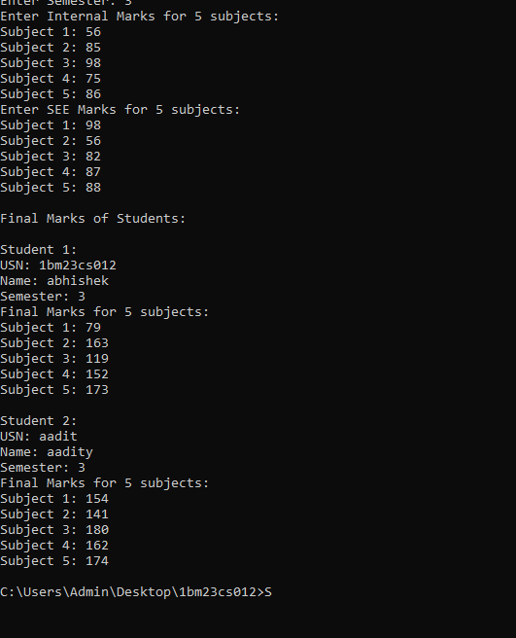

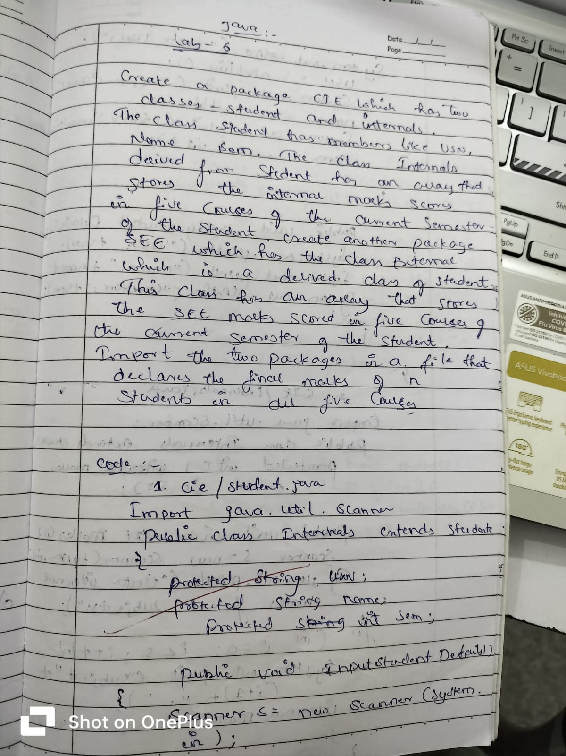
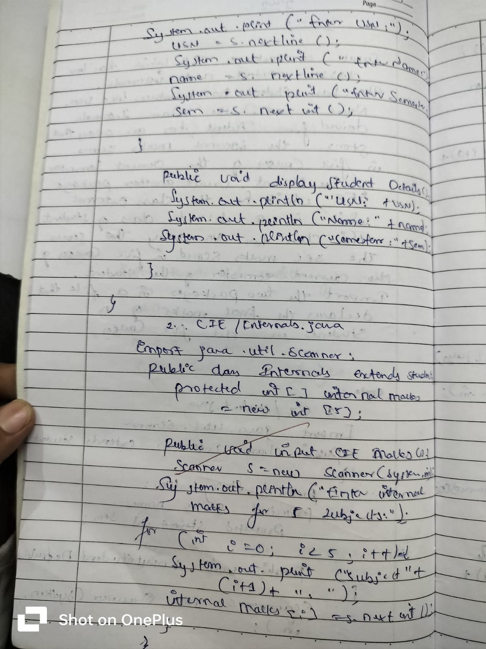
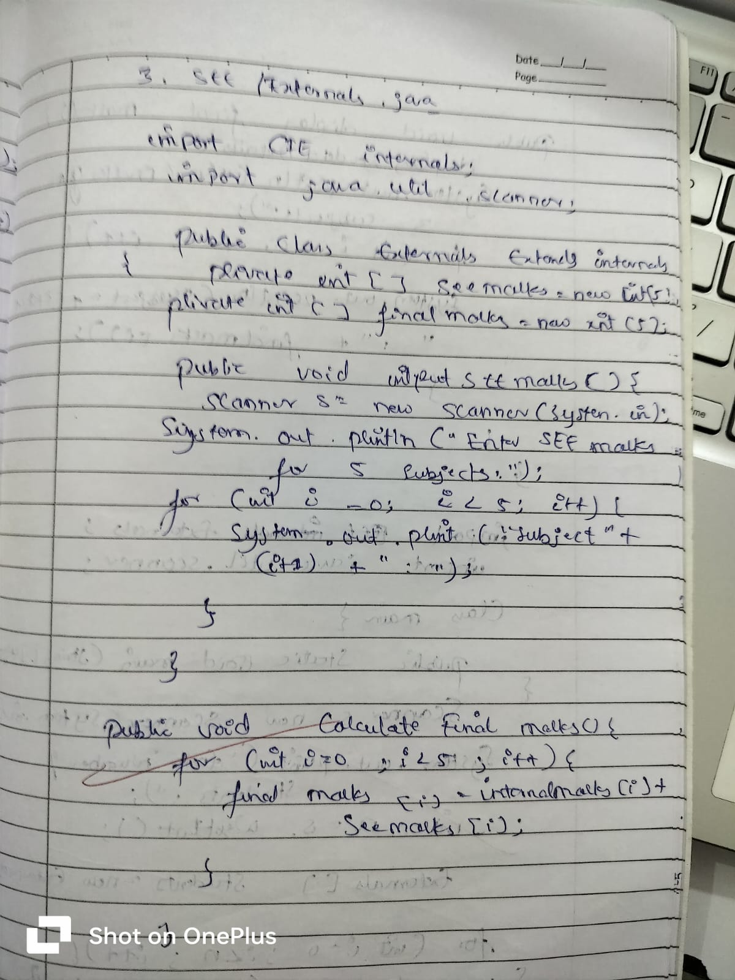
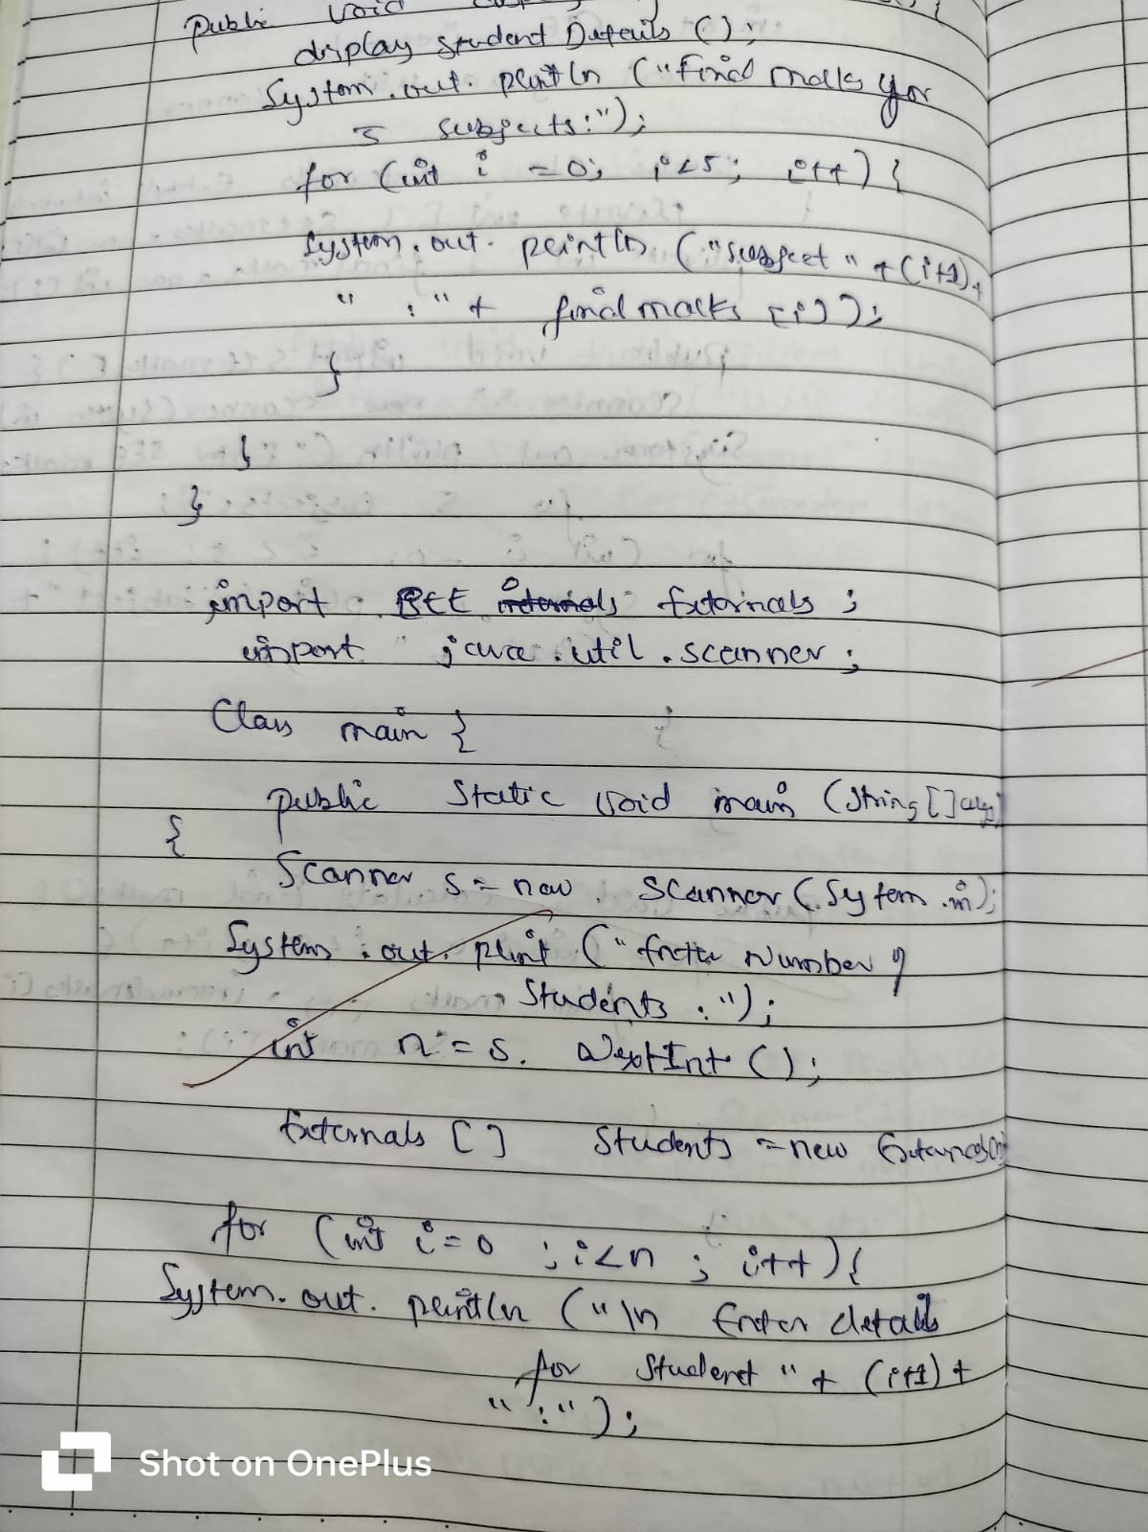
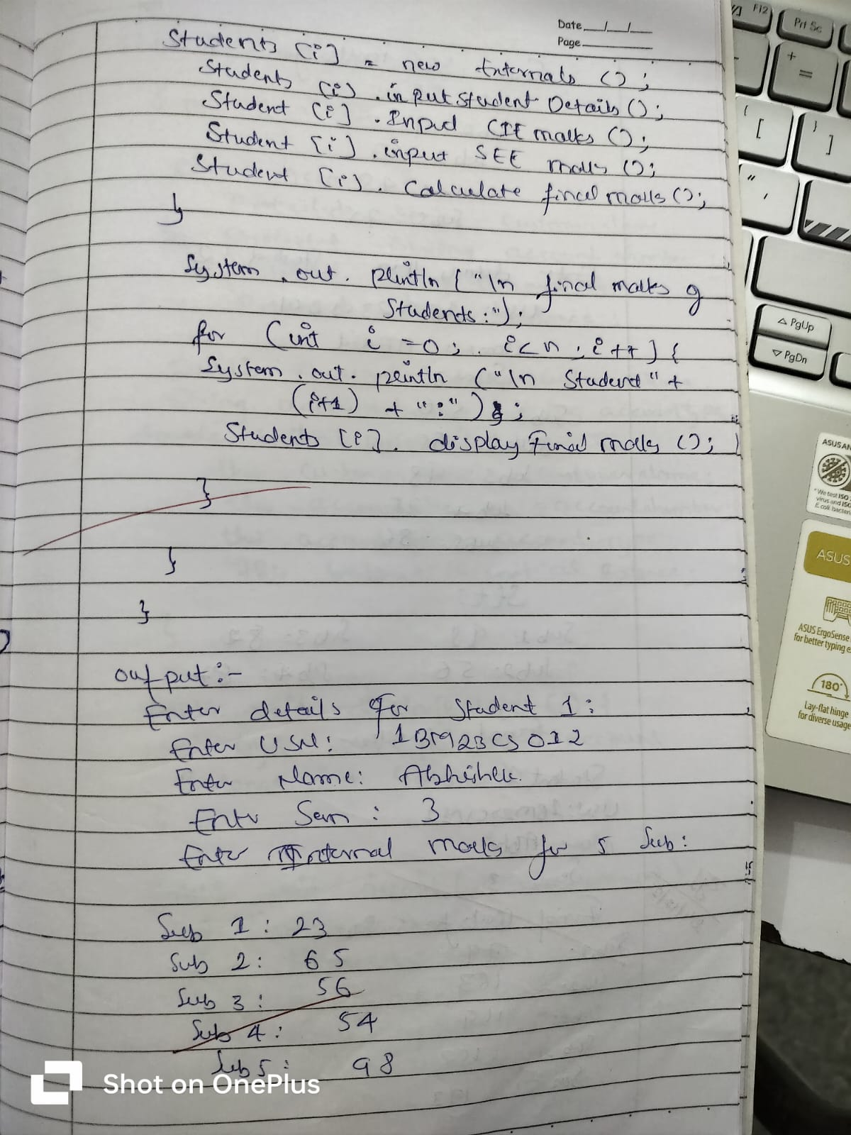
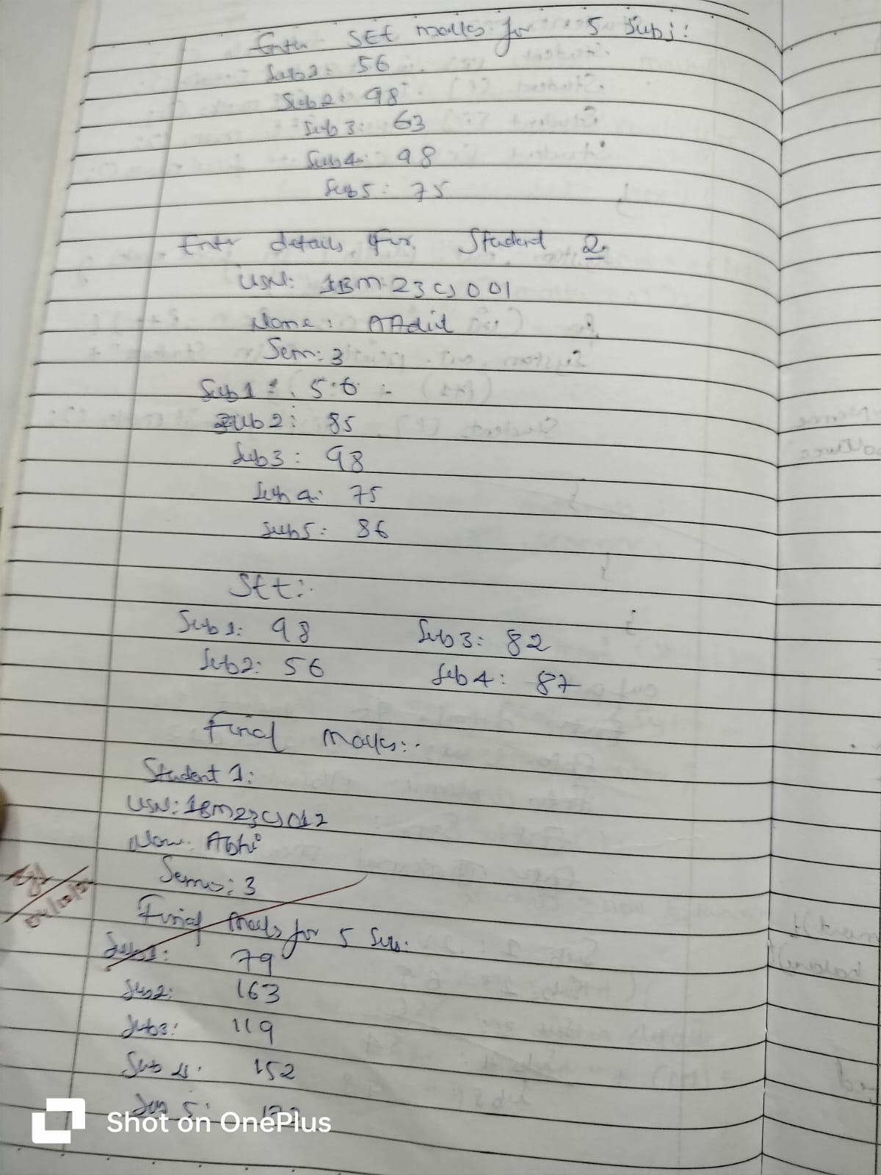

PROGRAM :7

Write a program that demonstrates handling of exceptions in inheritance tree. Create a base class called “Father” and derived class called “Son” which extends the base class. In Father class, implement a constructor which takes the age and throws the exception WrongAge( ) when the input age<0. In Son class, implement a constructor that uses both father and son’s age and throws an exception if son’s age is >=father’s age.

import java.util.Scanner;
class WrongAgeException extends Exception {
public WrongAgeException(String message) {
super(message);
}
}

class SonAgeException extends Exception {
public SonAgeException(String message) {
super(message);
}
}

class Father {
private int age;
public Father(int age) throws WrongAgeException {
if (age < 0) {
throw new WrongAgeException("Wrong age");
}
this.age = age;
}
public int getAge() {
return age;
}
}

class Son extends Father {
private int sonAge;
public Son(int fatherAge, int sonAge) throws WrongAgeException, SonAgeException {
super(fatherAge);
if (sonAge >= fatherAge) {
throw new SonAgeException("Son's age cannot be greater than or equal to father's age");
}
this.sonAge = sonAge;
}
public int getSonAge() {
return sonAge;
}
}
public class FatherSon{
public static void main(String[] args) {
while(true){
Scanner sc = new Scanner(System.in);
System.out.print("Enter Father's Age: ");
int fatherAge = sc.nextInt();
System.out.print("Enter Son's Age: ");
int sonAge = sc.nextInt();
try {
Son son = new Son(fatherAge, sonAge);
System.out.println("Accepted Succesfully");
}
catch (WrongAgeException e) {
System.out.println(e.getMessage());
}
catch (SonAgeException e) {
System.out.println(e.getMessage());
}
System.out.println("Would you like to re-enter details (Y/n)");
String input = sc.next();
if (input.equalsIgnoreCase("n")) {
break;
}
}
}
}

OUTPUT:
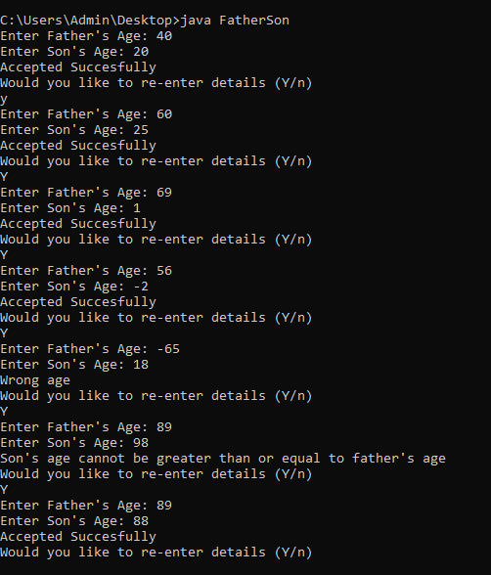
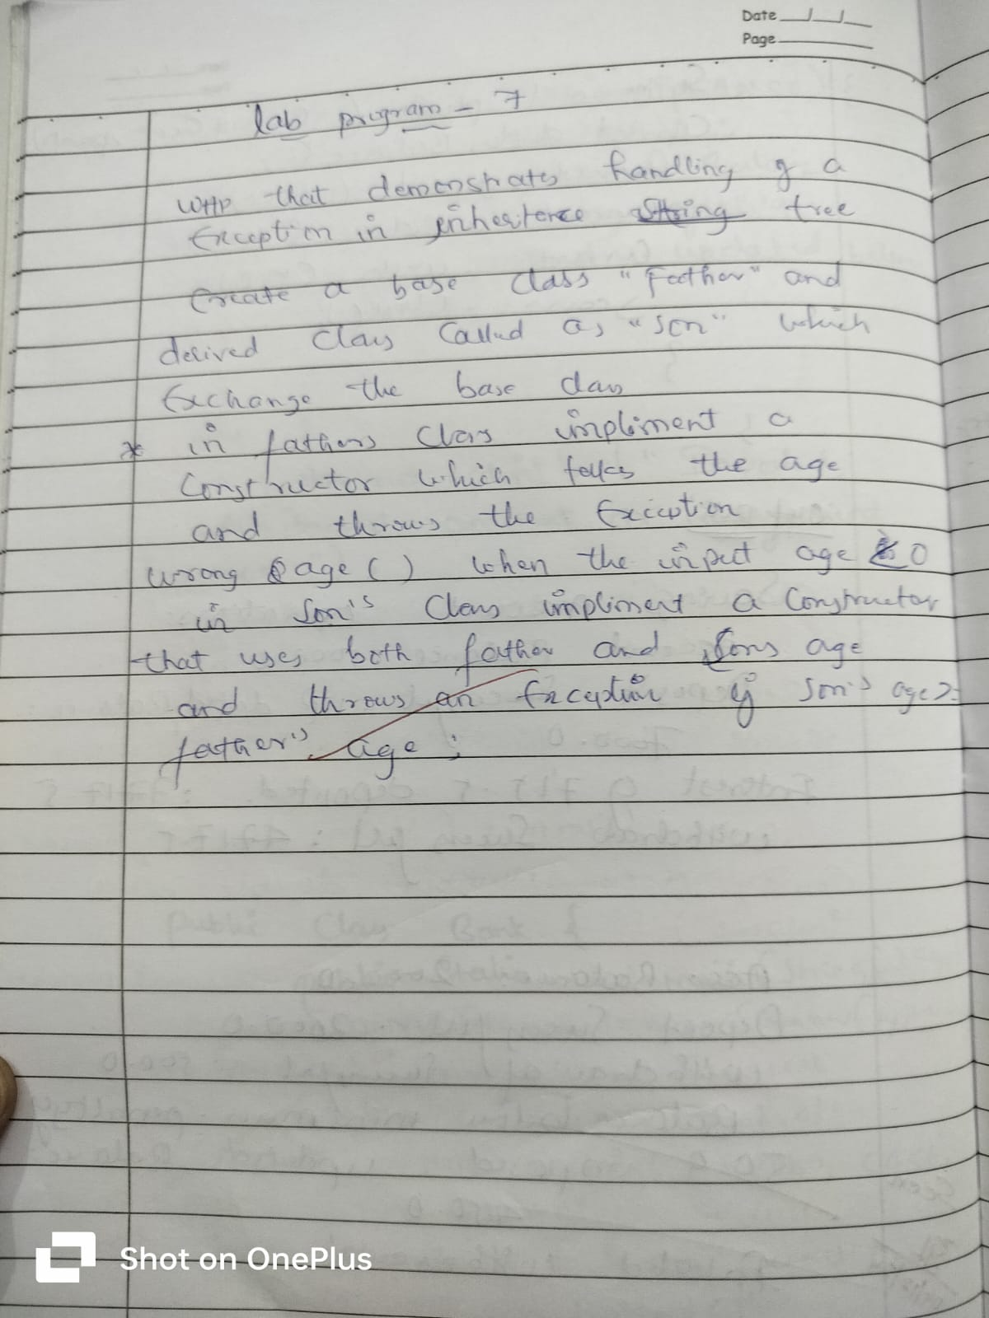
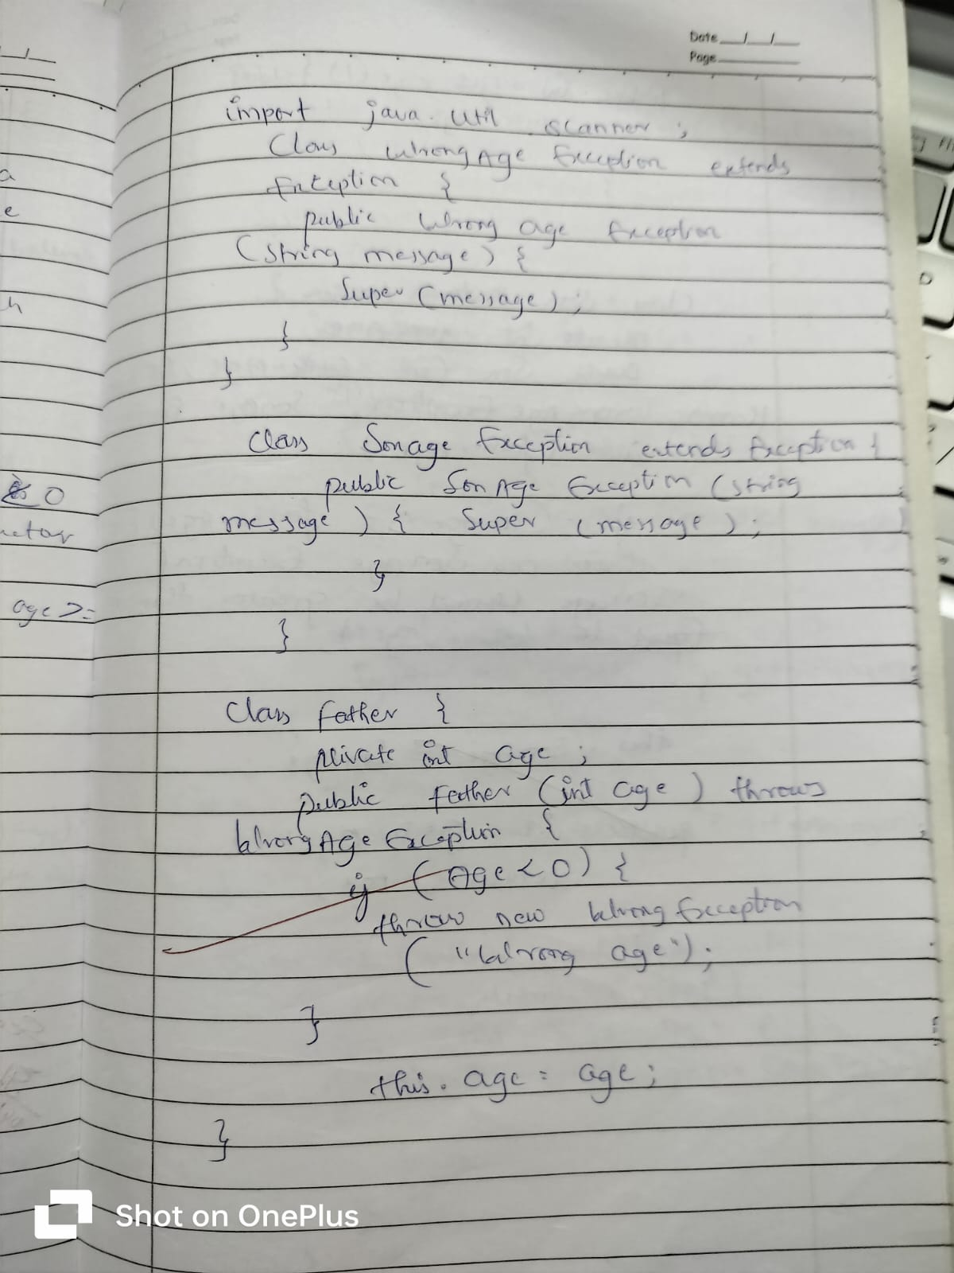
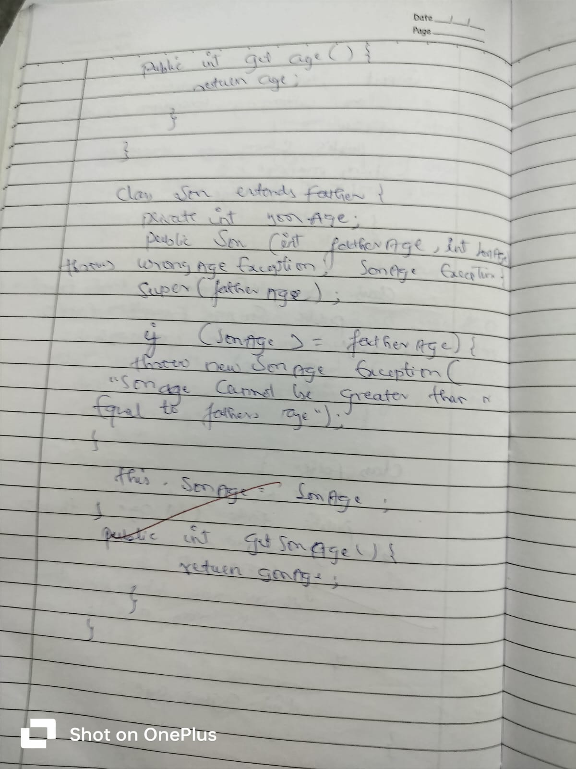
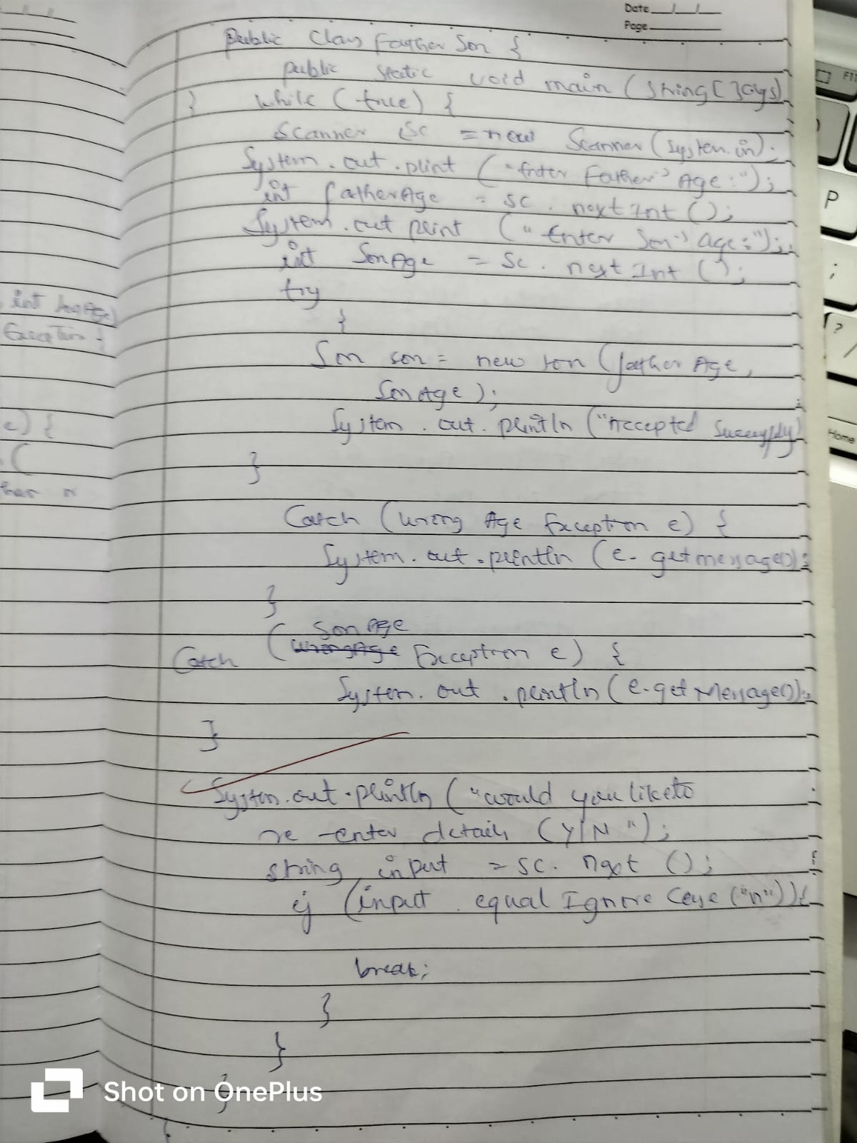
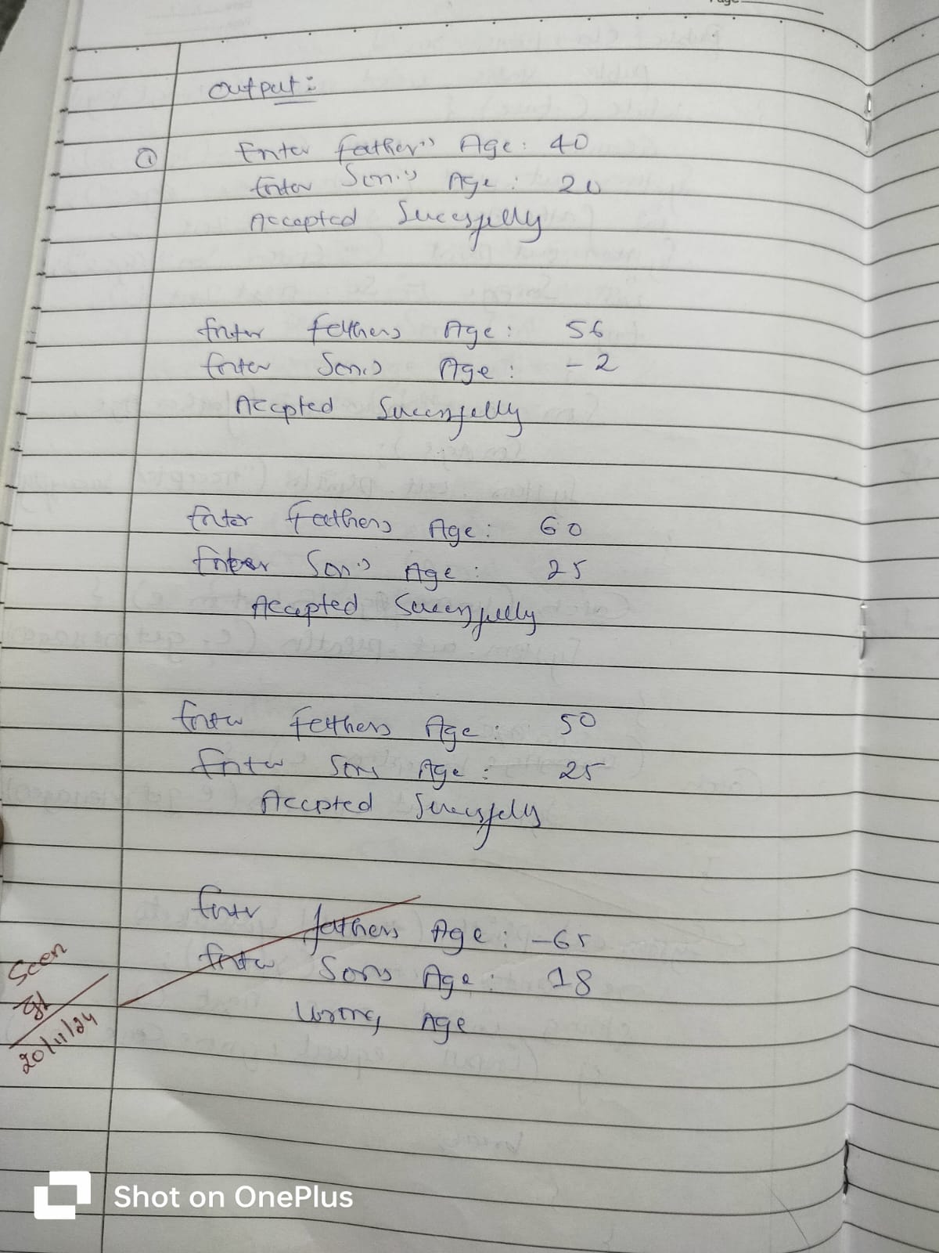
PROGRAM :8

Write a program which creates two threads, one thread displaying “BMS College of Engineering” once every ten seconds and another displaying “CSE” once every two seconds.

class FirstThread extends Thread {
public void run() {
while (true) {
System.out.println("BMS College of Engineering");
try {
Thread.sleep(10000);
} catch (InterruptedException e) {
System.out.println(e);
}
}
}
}

class SecondThread extends Thread {
public void run() {
while (true) {
System.out.println("CSE");
try {
Thread.sleep(2000);
} catch (InterruptedException e) {
System.out.println(e);
}
}
}
}

class thread{
public static void main(String[] args) {

FirstThread thread1 = new FirstThread();
SecondThread thread2 = new SecondThread();

thread1.start();
thread2.start();
}
}

OUTPUT:

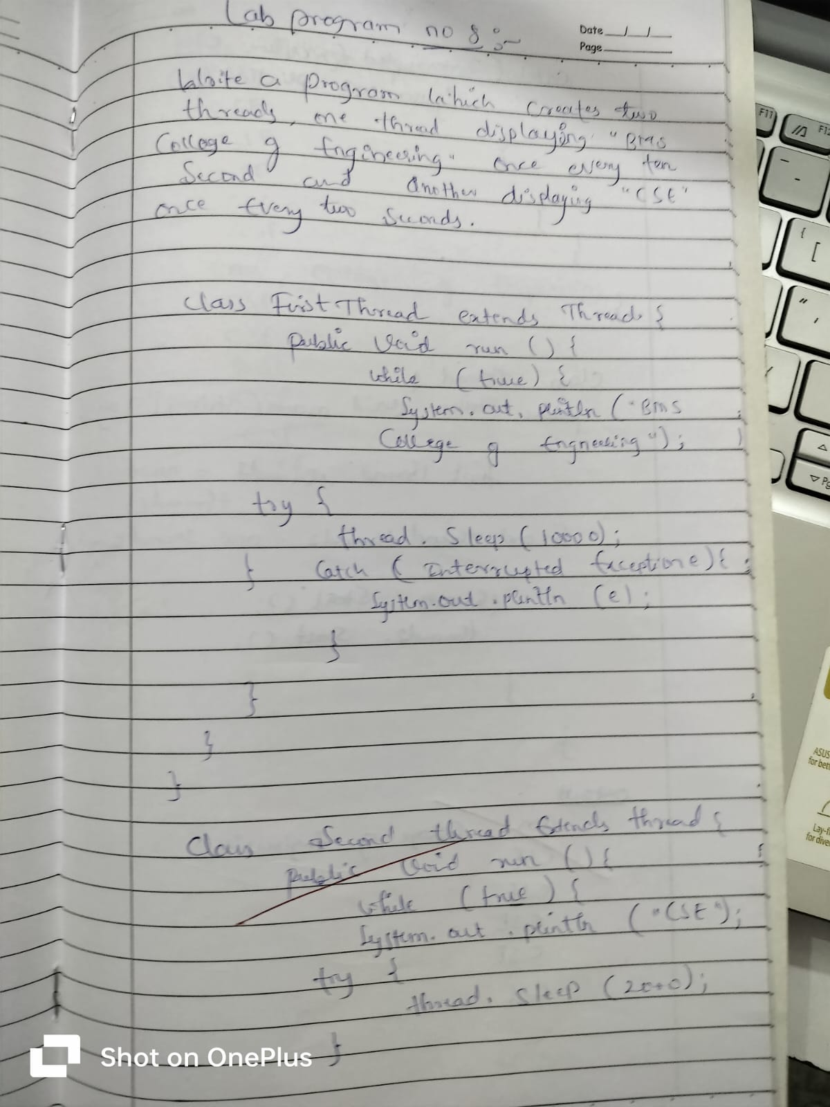
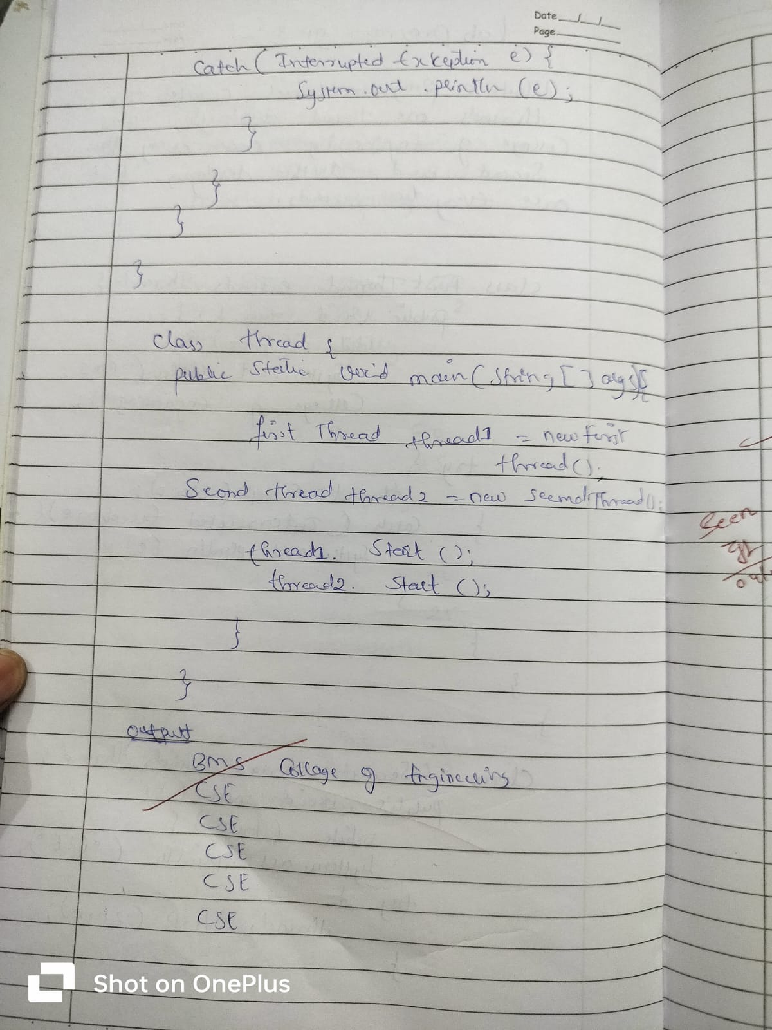
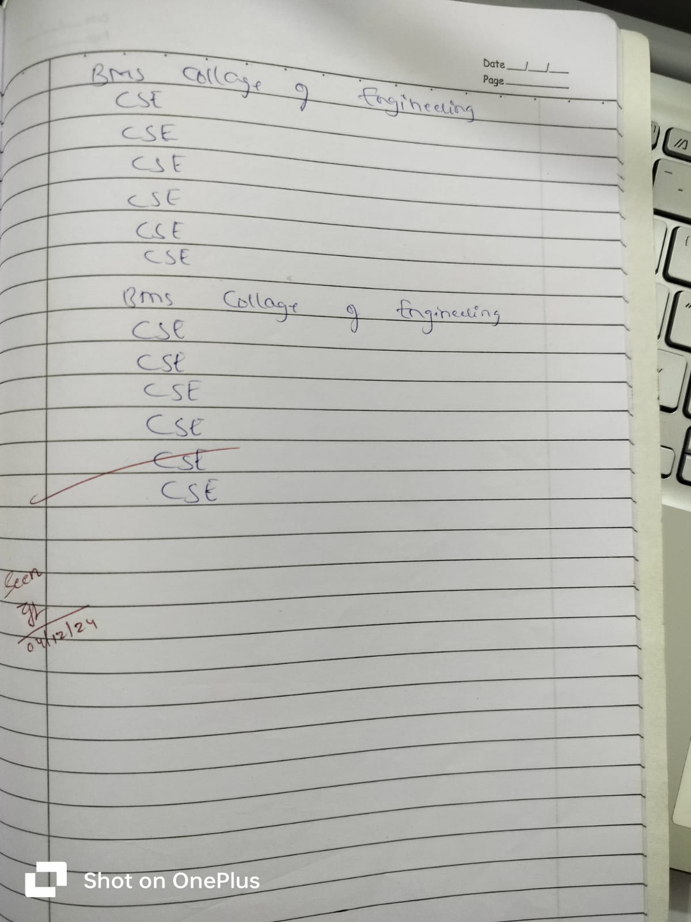
9)) Write a program that creates a user interface to perform
integer divisions. The user enters two numbers in the text
fields, Num1 and Num2. The division of Num1 and Num2
is displayed in the Result field when the Divide button is
clicked. If Num1 or Num2 were not an integer, the
program would throw a NumberFormatException. If Num2
were Zero, the program would throw an Arithmetic
Exception Display the exception in a message dialog box.

Code ::

import javax.swing.*;
import java.awt.*;
import java.awt.event.*;
class SwingDemo{
SwingDemo(){
// create jframe container
JFrame jfrm = new JFrame("Divider App");
jfrm.setSize(275, 150);
jfrm.setLayout(new FlowLayout());
// to terminate on close
jfrm.setDefaultCloseOperation(JFrame.EXIT_ON_CLOSE);
// text label
JLabel jlab = new JLabel("Enter the divider and divident:");
// add text field for both numbers
JTextField ajtf = new JTextField(8);
JTextField bjtf = new JTextField(8);
// calc button
JButton button = new JButton("Calculate");
// labels
JLabel err = new JLabel();
JLabel alab = new JLabel();
JLabel blab = new JLabel();

JLabel anslab = new JLabel();
// add in order :)
jfrm.add(err); // to display error bois
jfrm.add(jlab);
jfrm.add(ajtf);
jfrm.add(bjtf);
jfrm.add(button);
jfrm.add(alab);
jfrm.add(blab);
jfrm.add(anslab);
ActionListener l = new ActionListener() {
public void actionPerformed(ActionEvent evt) {
System.out.println("Action event from a text field");
}
};
ajtf.addActionListener(l);
bjtf.addActionListener(l);
button.addActionListener(new ActionListener() {
public void actionPerformed(ActionEvent evt) {
try{
int a = Integer.parseInt(ajtf.getText());
int b = Integer.parseInt(bjtf.getText());
int ans = a/b;
alab.setText("\nA = " + a);
blab.setText("\nB = " + b);
anslab.setText("\nAns = "+ ans);
}
catch(NumberFormatException e){
alab.setText("");
blab.setText("");
anslab.setText("");

err.setText("Enter Only Integers!");
}
catch(ArithmeticException e){
alab.setText("");
blab.setText("");
anslab.setText("");
err.setText("B should be NON zero!");
}
}
});
// display frame
jfrm.setVisible(true);
}
public static void main(String args[]){
// create frame on event dispatching thread
System.out.println("USN: 1BM23CS003 \nName: Aaron B Ajay");
SwingUtilities.invokeLater(new Runnable(){
public void run(){
new SwingDemo();
}
});
}
}

Output:

